SSC - Process Document
Summary:
Smith Street Capital is the main process from the Client named Duncan Frearson. Process will be done with the tickers which is registered with NYSE. Need the fetch the financial data for the last 10 years from Edgar Pro. The ticker should not be acquired.
Enter the ticker in the yahoo finance. And select the ticker in the drop down as given below, If the ticker appears with the company name. Or else check whether the company is acquired or not

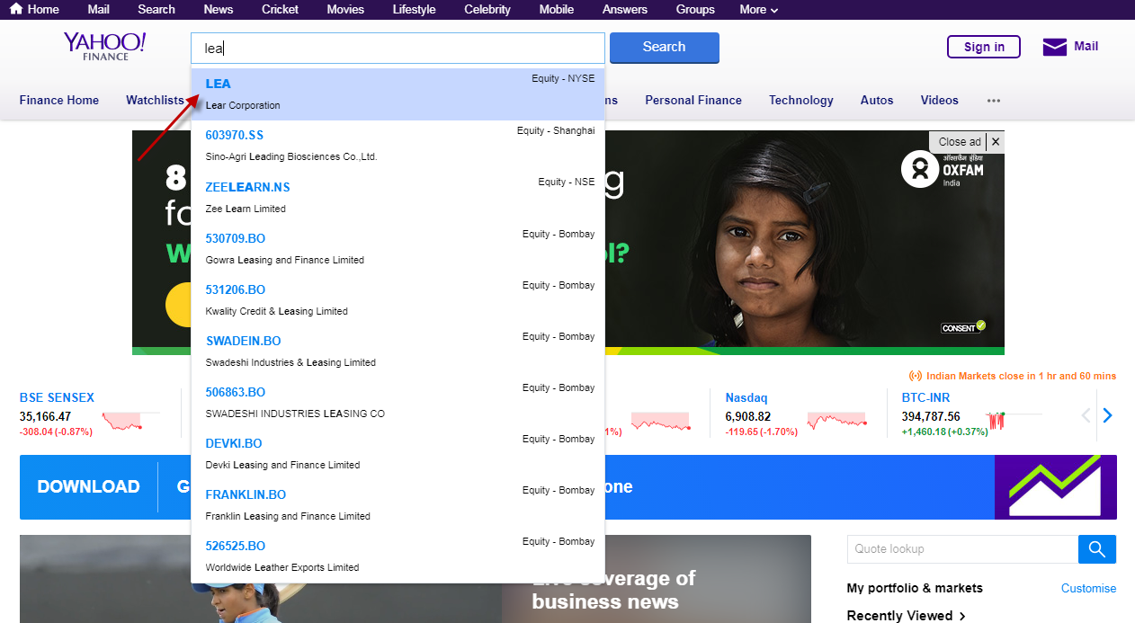
Go to statistics as given below to check the fiscal year ends
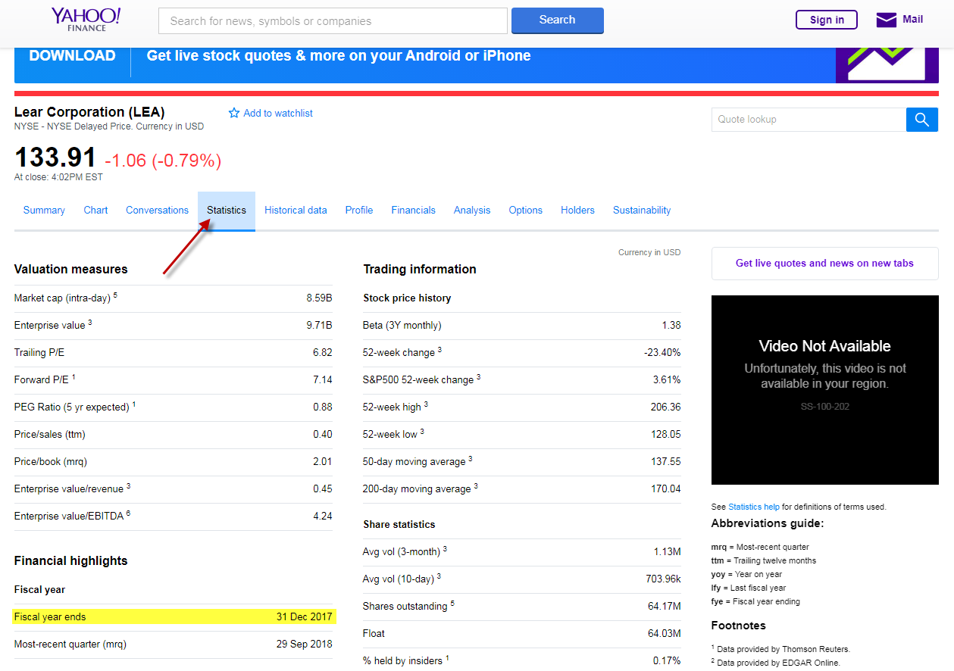
User Name & Pass Word for Edgar Pro:
User Name: dfrearson1
This is the main site where we gonna take the financial data for the last 10 years of annual data & last 2 years of Quarter data. 1st step is to enter the ticker in the search box and select the appropriate ticker in the listed tickers
Password: shares2015

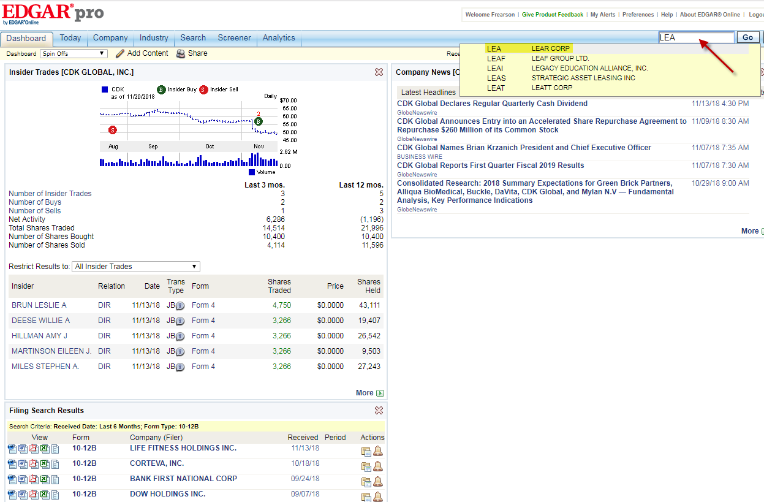
There are three main things to enter in the financial data. They are Cash Flow, Balance Sheet & Income Statement. Cash flow & Balance Sheet will be given at the left side on Edgar Pro. And it will contains the last 2 Years Quarterly Data & Last 5 years annual data. The procedure has given below

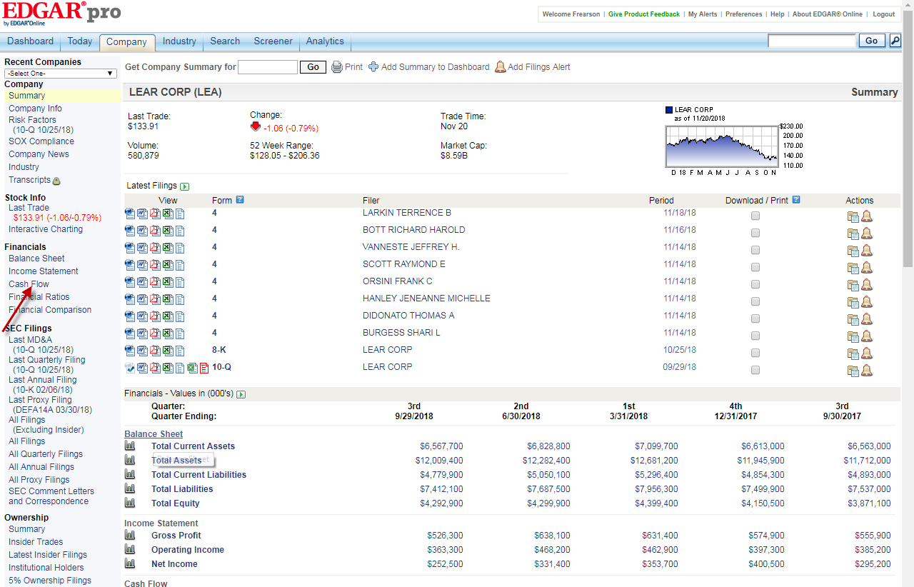

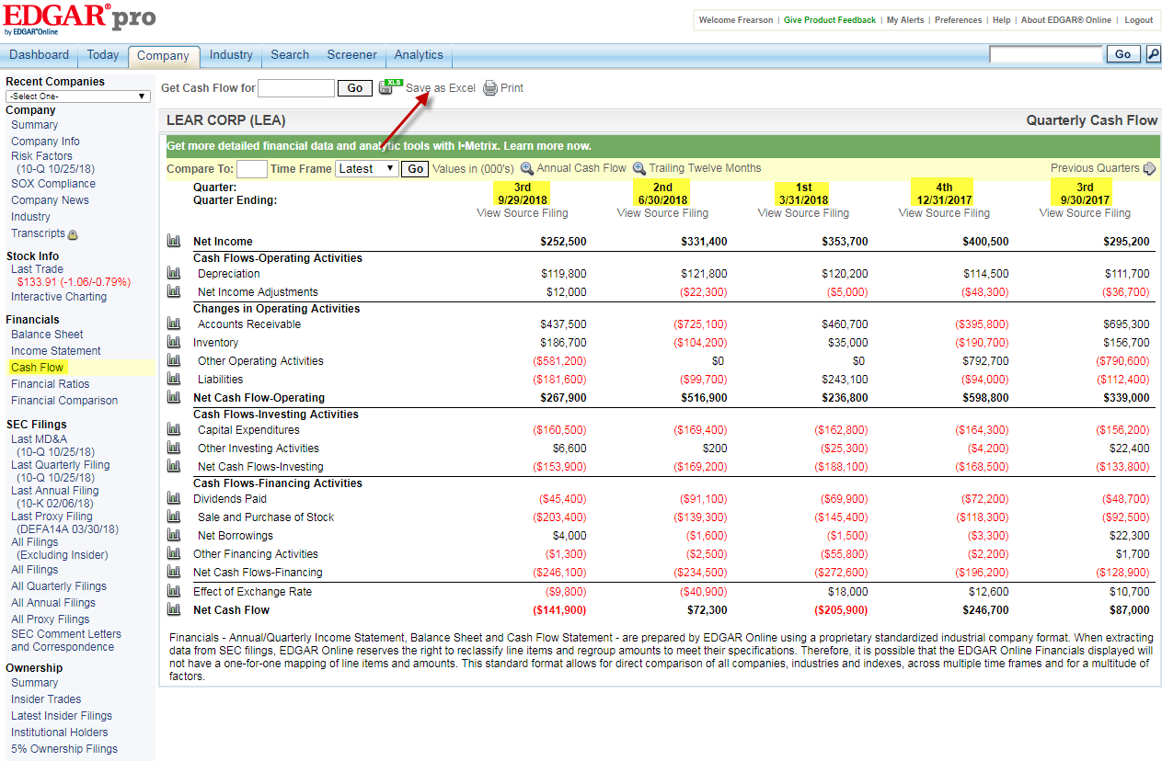
After selecting the cash flow, Quarterly Cash flow data will appear as given below, But It doesn’t have the 1st & 2nd Quarter of 2017. To check that, click the Previous Quarters. Click on the save as excel option to download the respective page
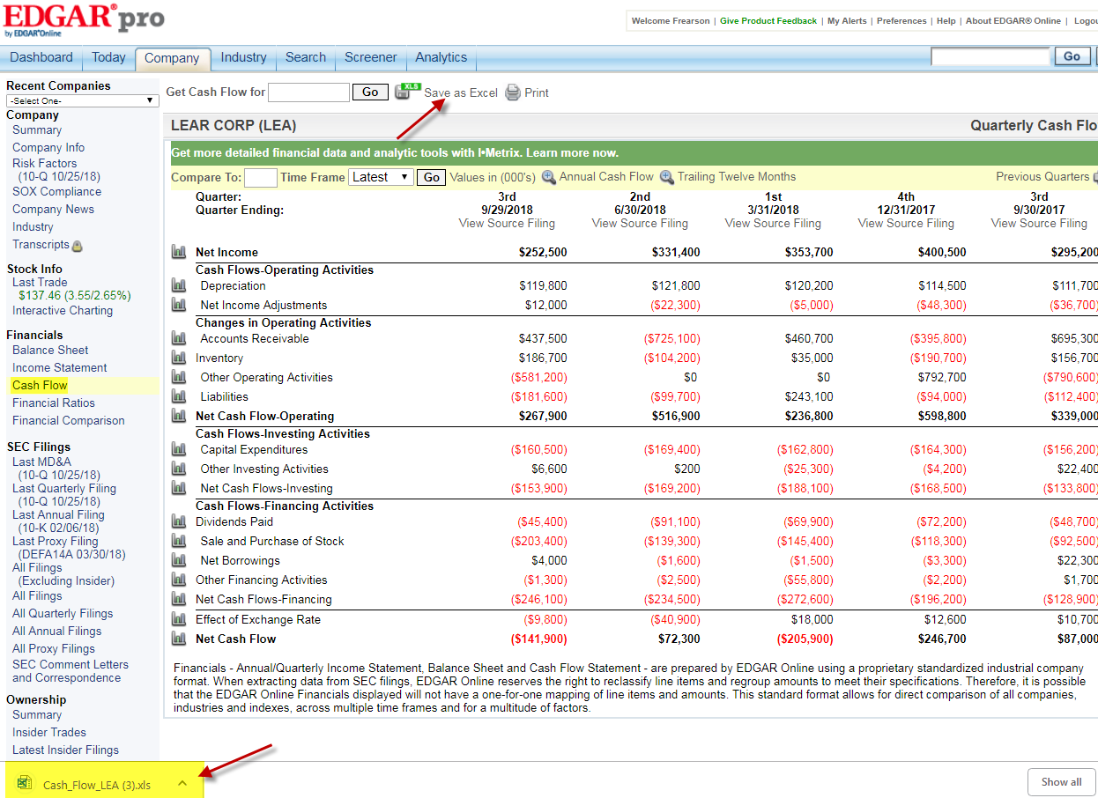

Downloaded excel will be like this.
Need to enter the values in the respective fields for the last 2 years

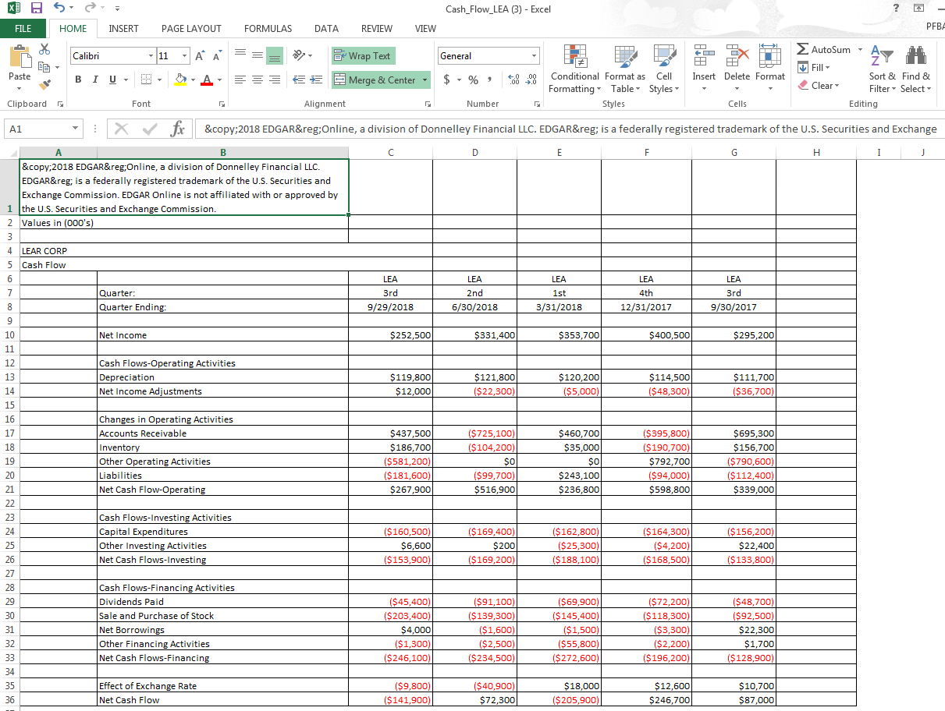
Enter the values in the template as given below
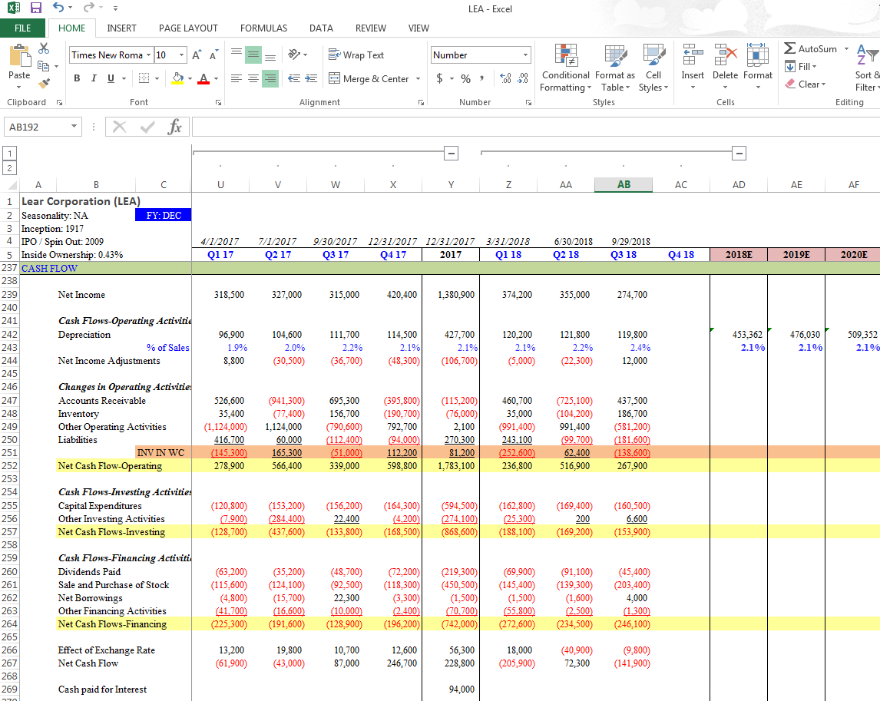
1st & 2nd quarter of 2017 is available on the next sheet. To check the annual data. Click on the annual cash flow.
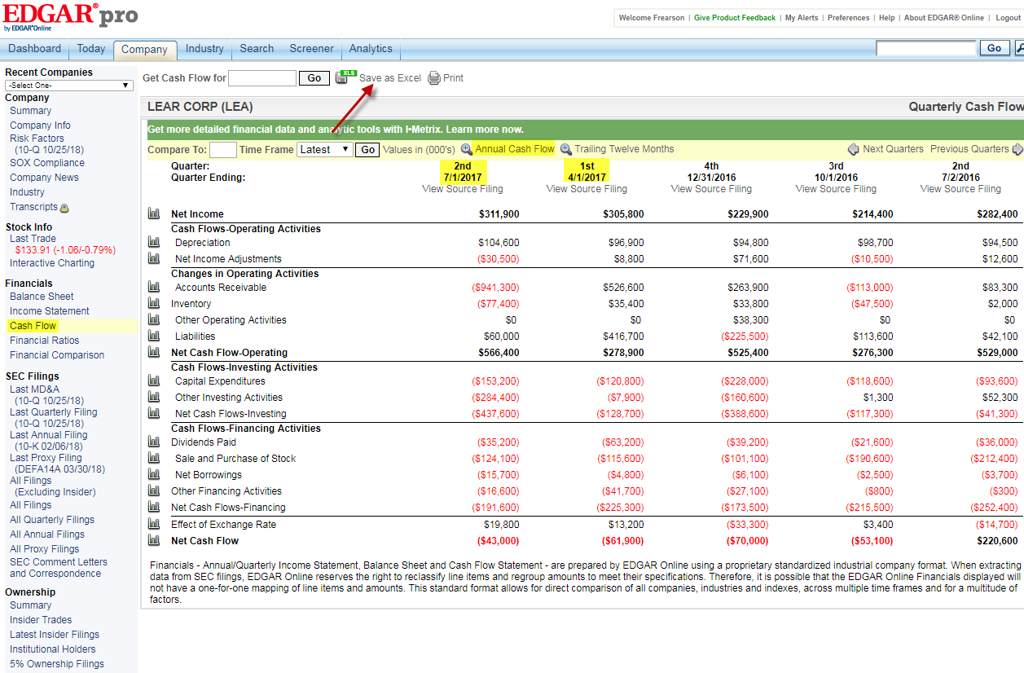
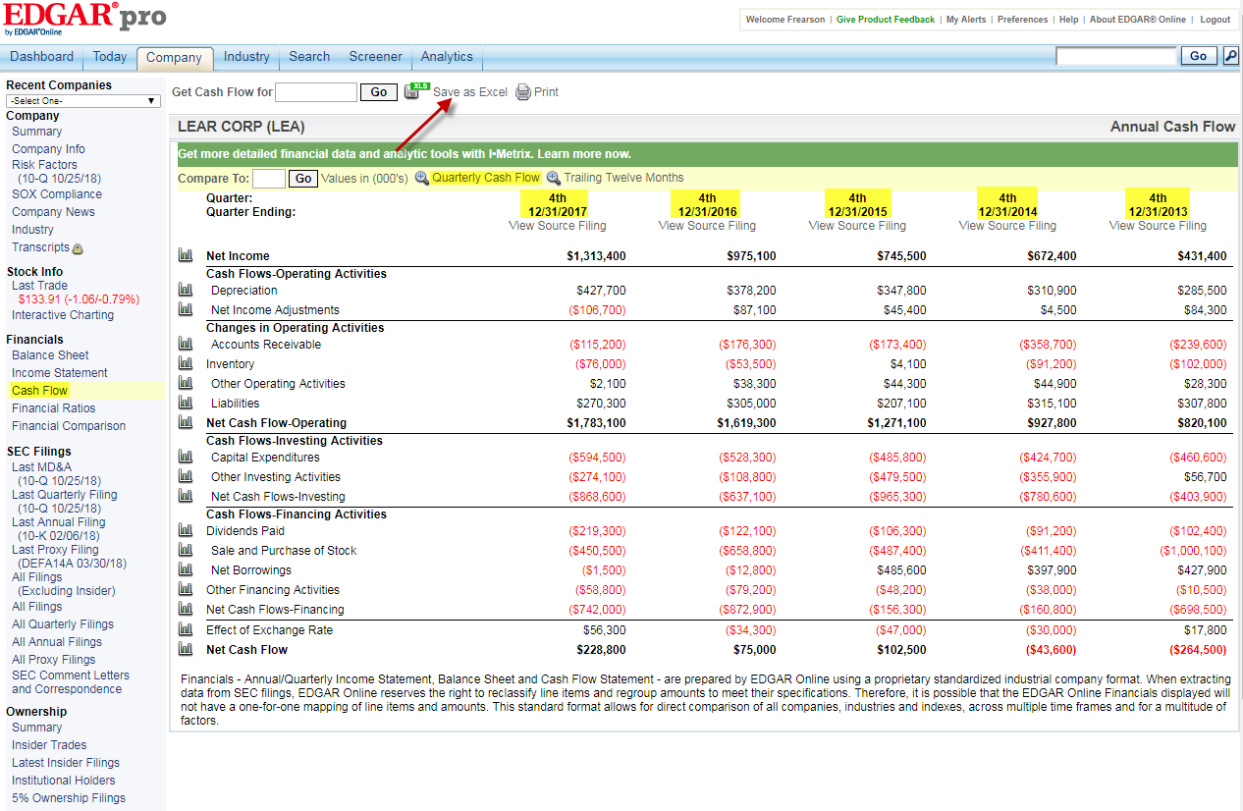
The last 5 years of annual cash flow data will displayed by clicking the annual cash flow. Now, need to download the excel & paste the values in the respective fields as given below
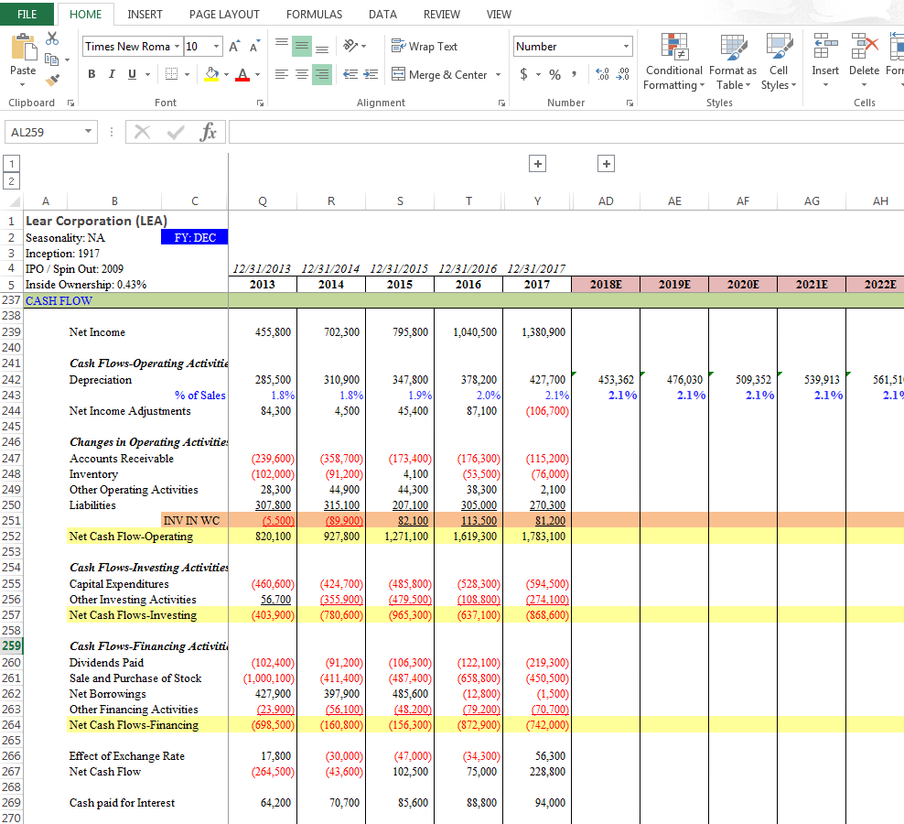
Click on the balance sheet on the left side to enter the Quarterly values of the last 2 years. And click save as excel to download & enter the values in the template. After finishing this, select the previous quarter to check the 1st & 2nd quarter of 2017

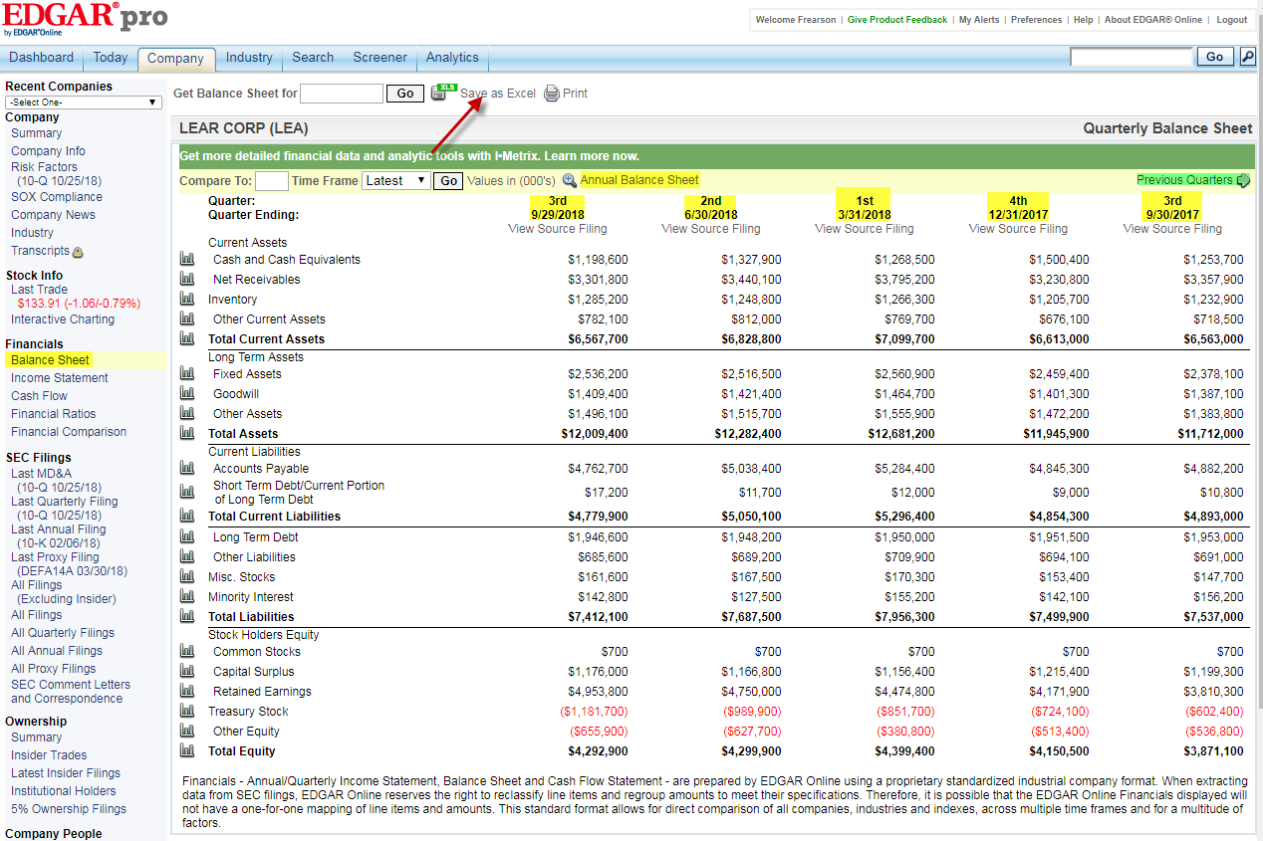
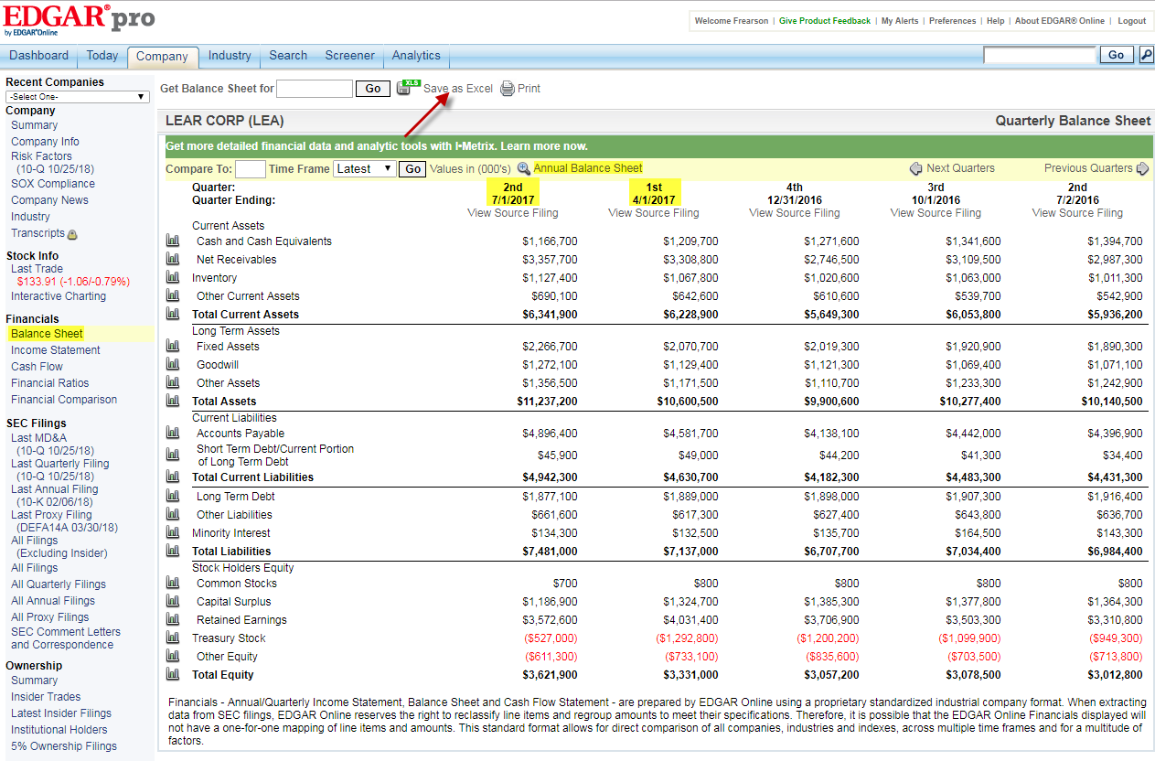
This is how the excel looks after entering the quarterly values in the SSC Template

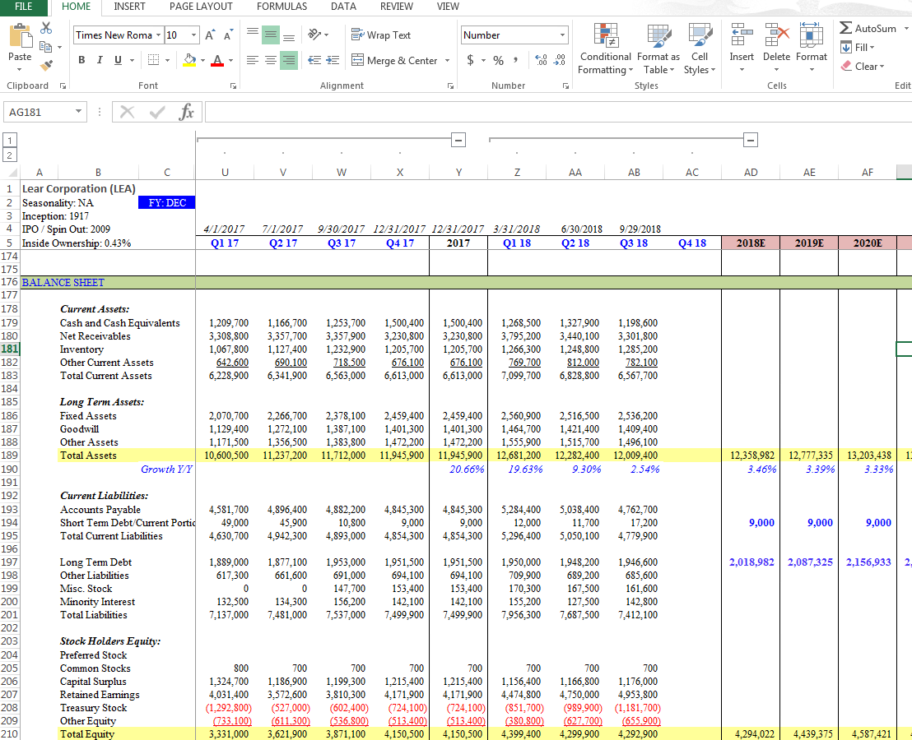
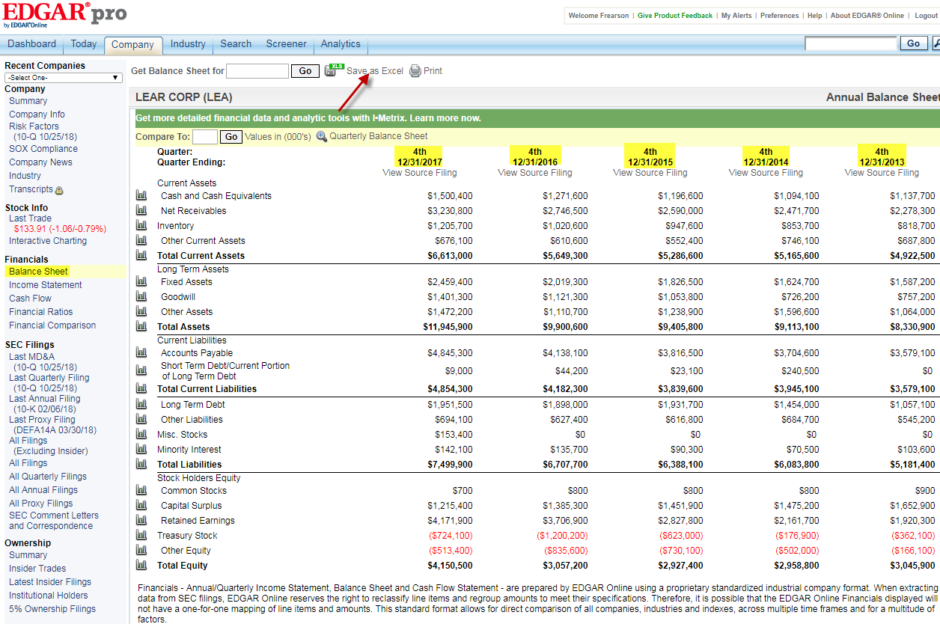
Click on the annual balance sheet to check the last 5 years annual financial data of balance sheet. Click the save as excel to download and enter the values in SSC template
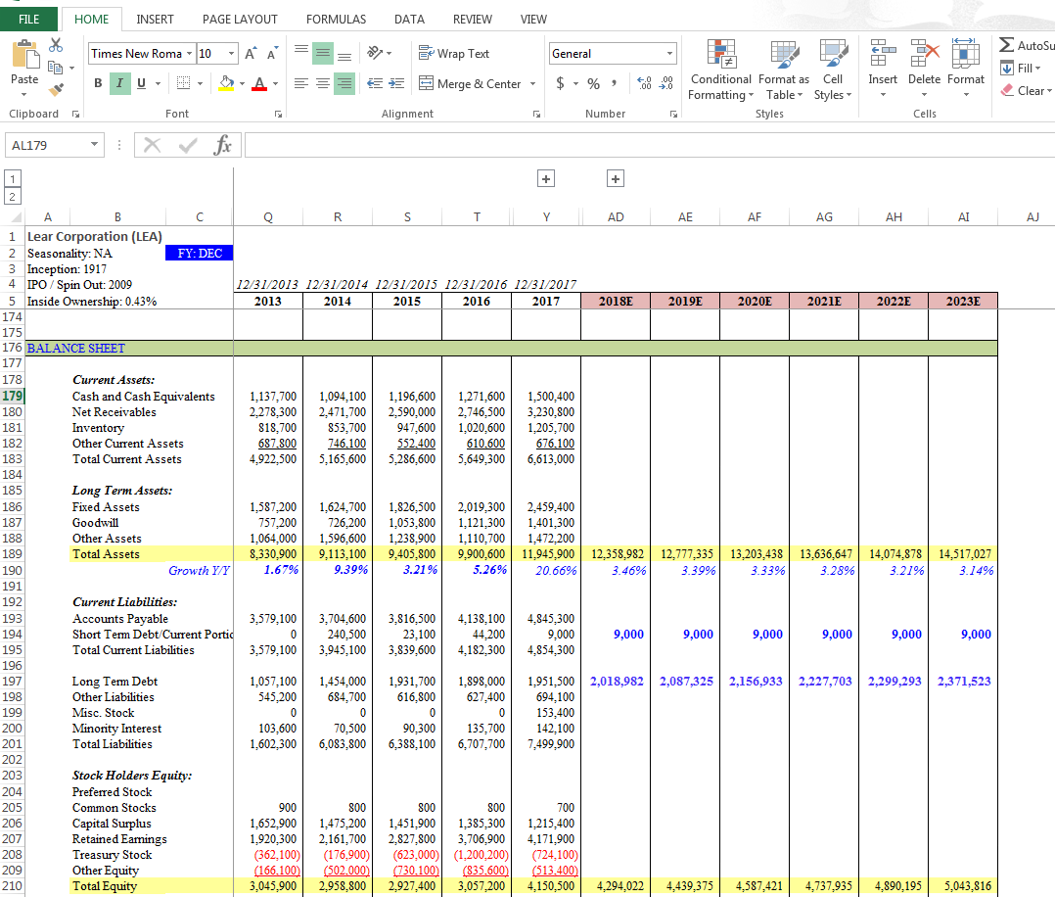
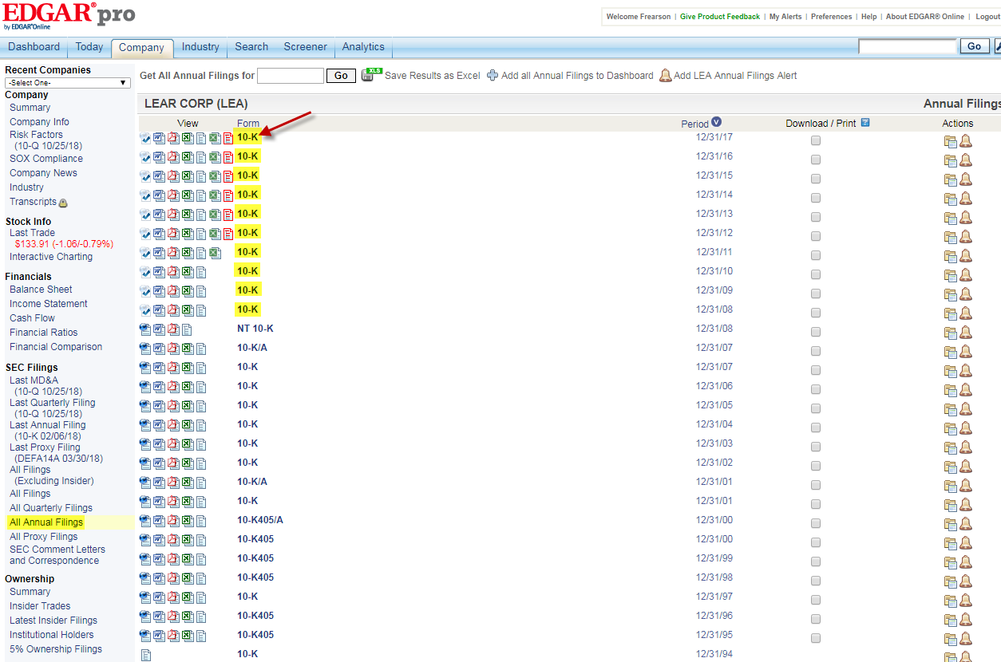
Select the All Annual Filings to open the 10-k form (Annual financial data). Open the last 10 years 10-k form as given below. Click on the 10-K under the form column to open the form
Click on the View Entire 10-k Filing
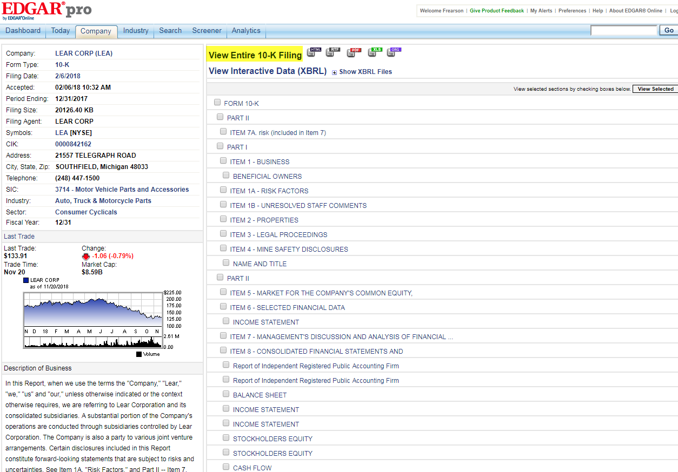
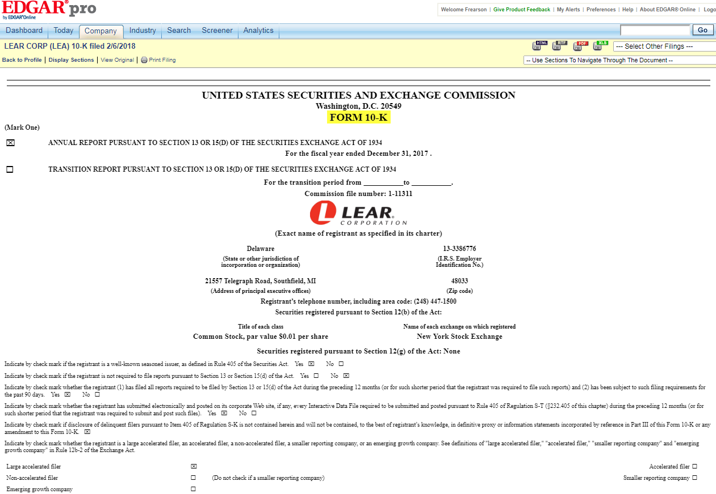
10-K Form will be like this
Scroll down to the form and select the Consolidated Financial Statement & Supplementary Data as given below
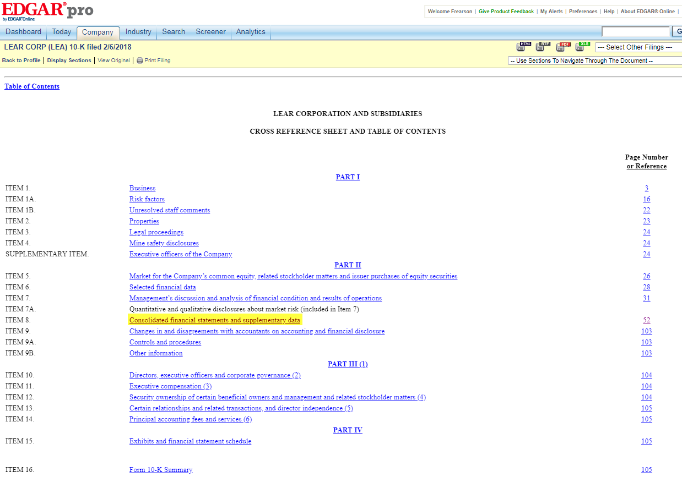
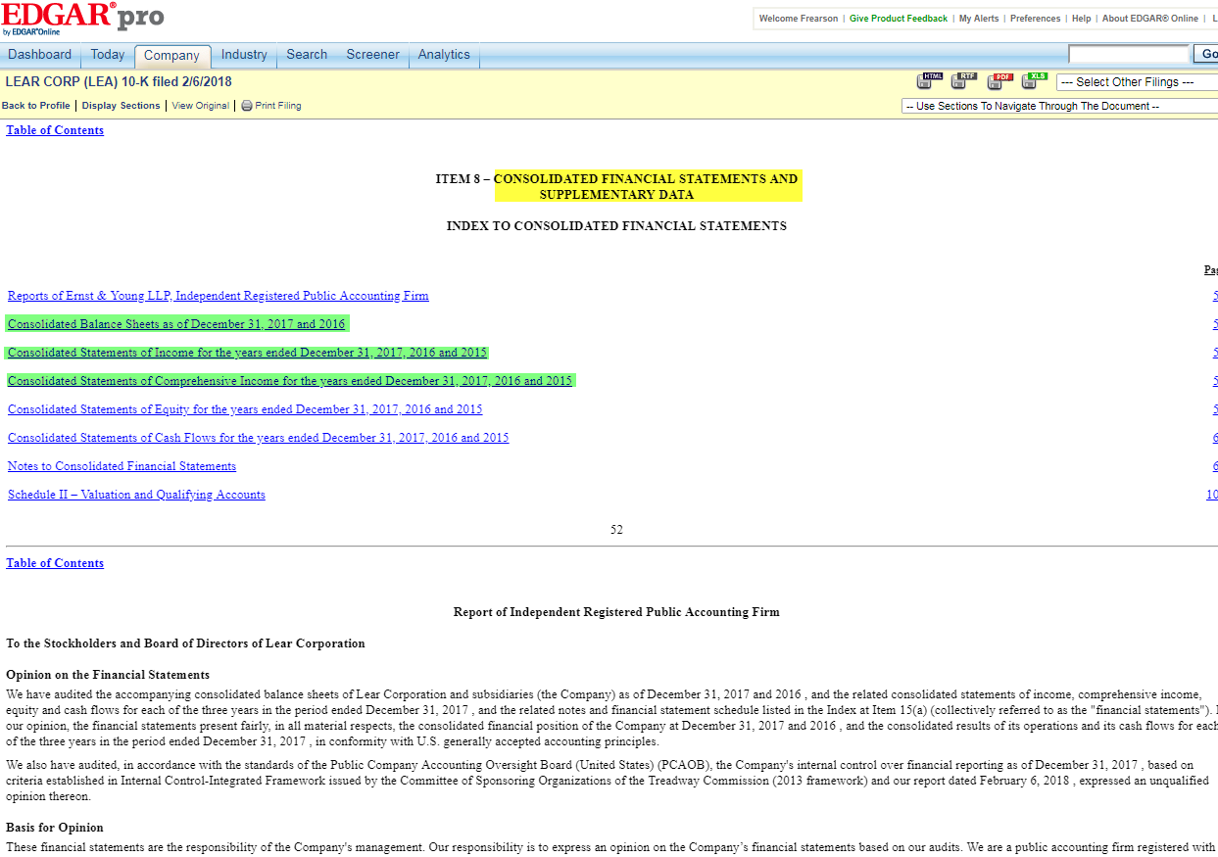
Balance Sheet will be given like this. Years will be mentioned at the top. Open the 12/31/13 10-k form to enter the 2012 values by cross checking the 2013 values we have entered on template. Likewise open rest of the 10-k forms and enter the values up to the year 2008.
Select the Consolidated Balance Sheets to fetch the financial data for the respective years

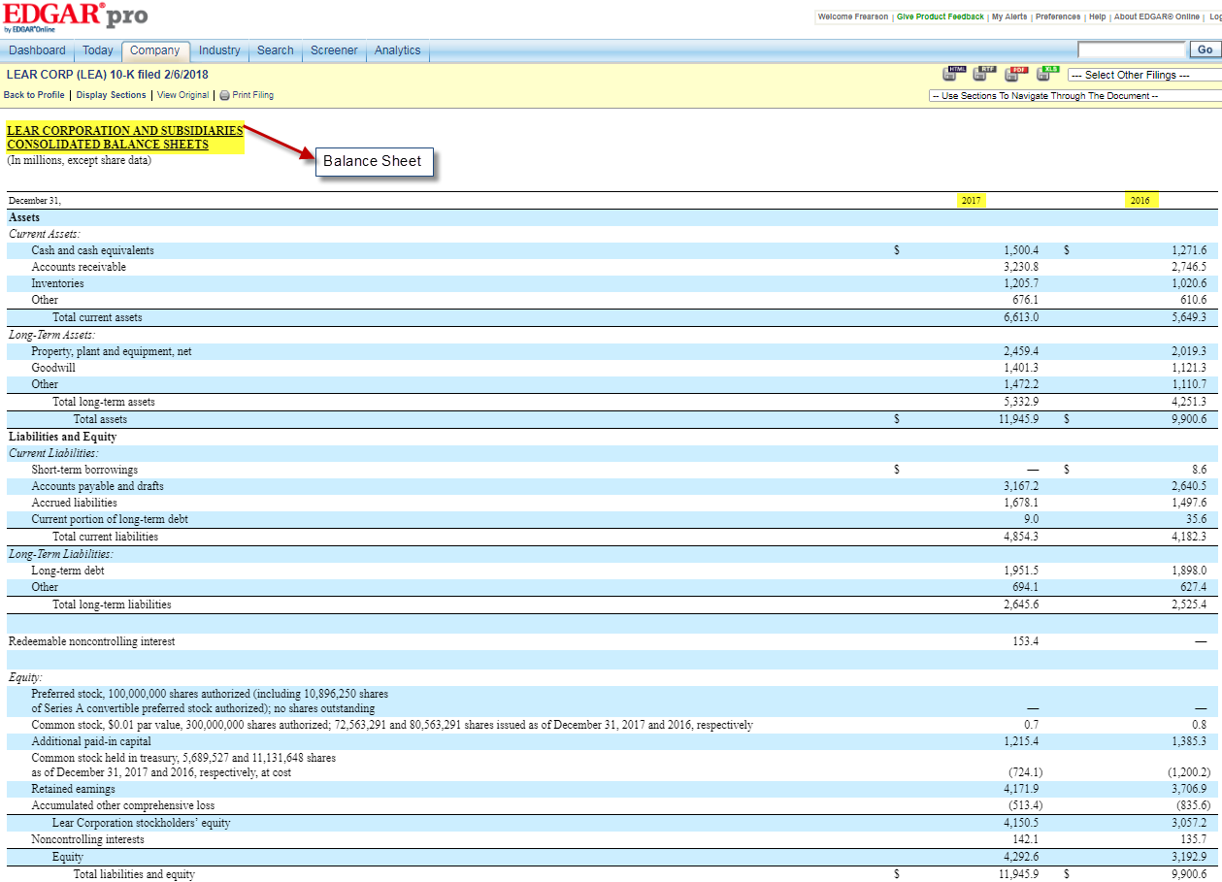
Balance sheet with 10 years value updated have given below
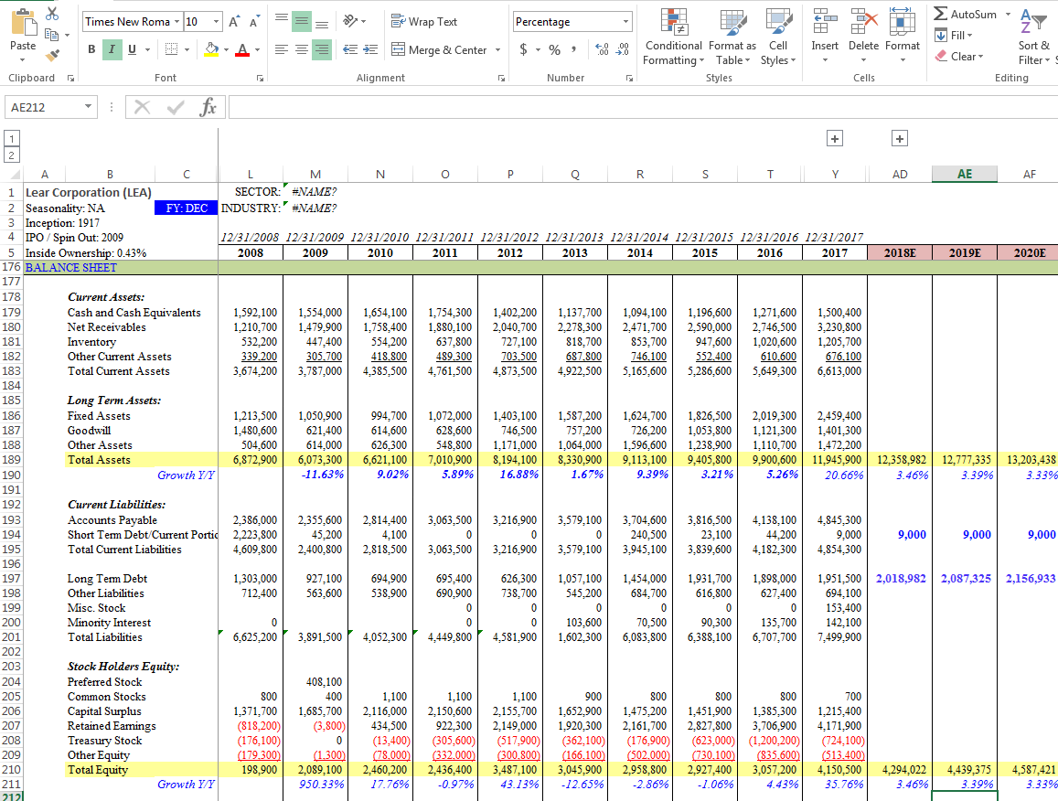
The income statement given next to the balance sheet. Values appear for three years. Open all the 10-k forms to enter the 10 years value of income statement

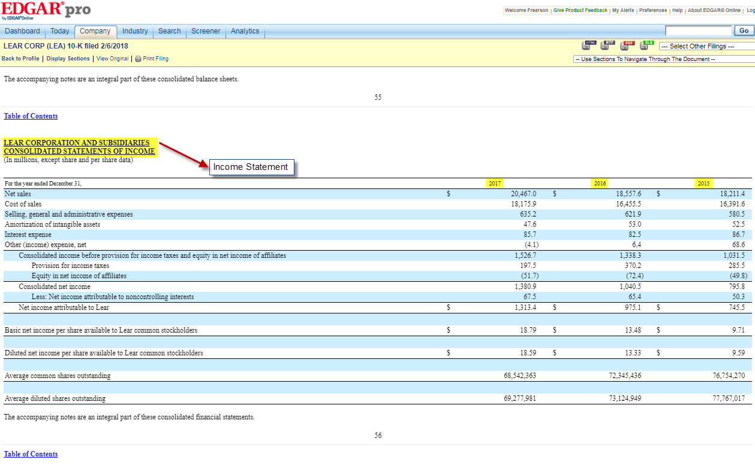
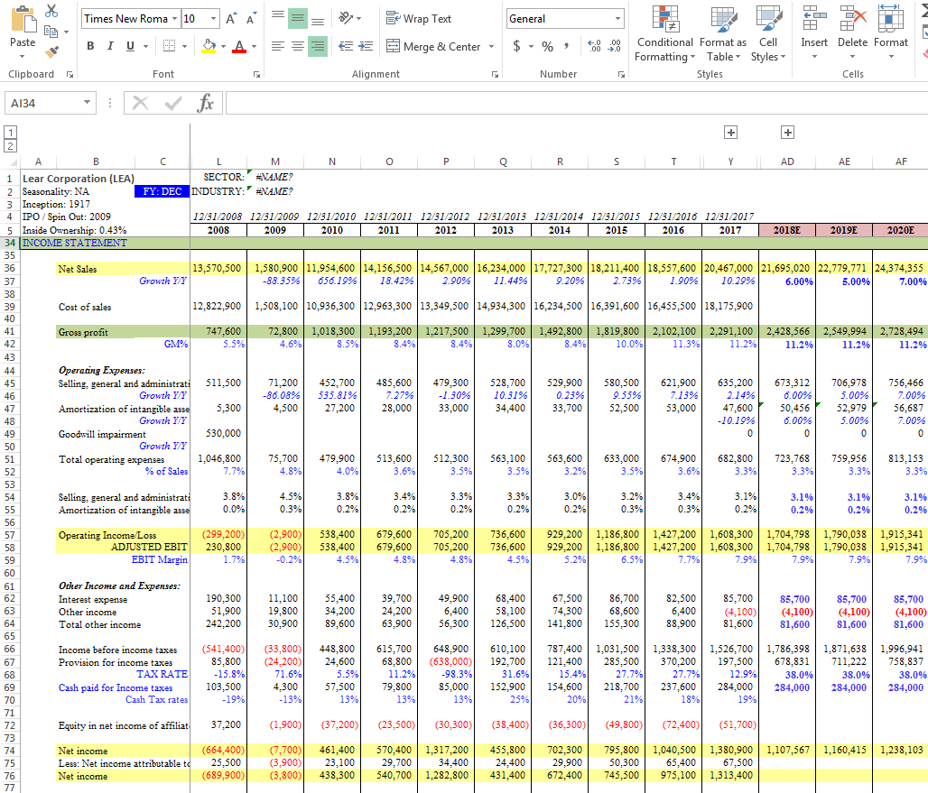
After entered all the 10 year values, Income Statement will be like
Cash flow will appear next to the income statement. Values appear for three years. Open all the 10-k forms to enter the 10 years value of Cash Flow
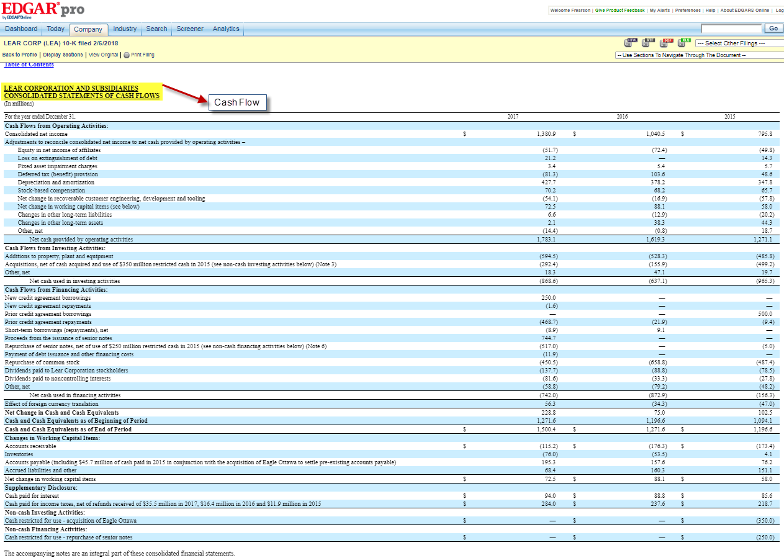
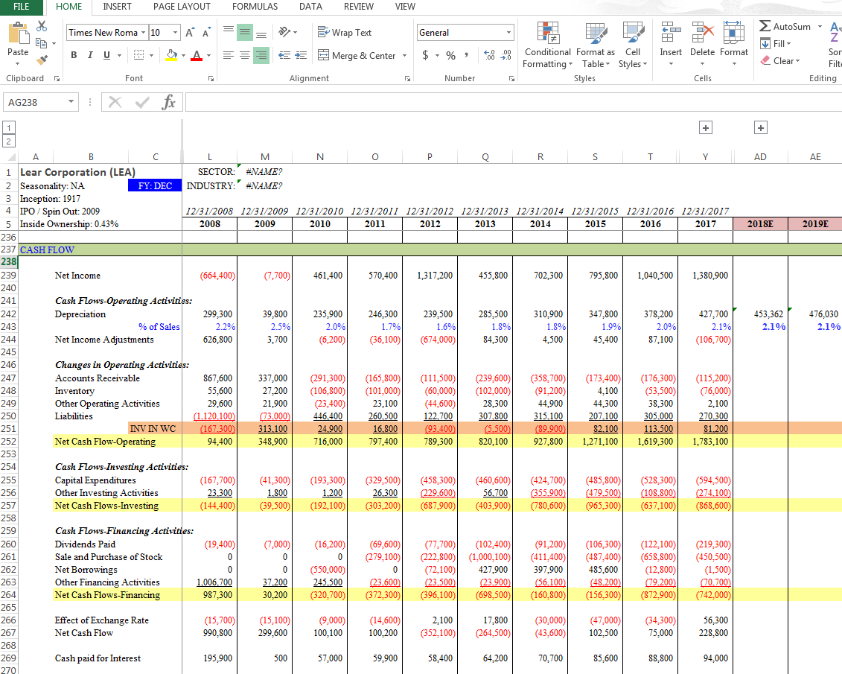
After entered all the 10 year values, Cash Flow will be like

Shares outstanding will be given on the 1st page of 10-K & 10-Q
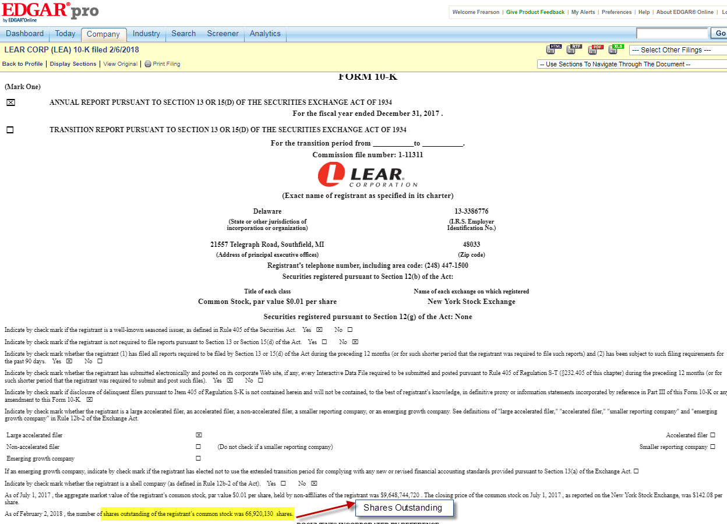
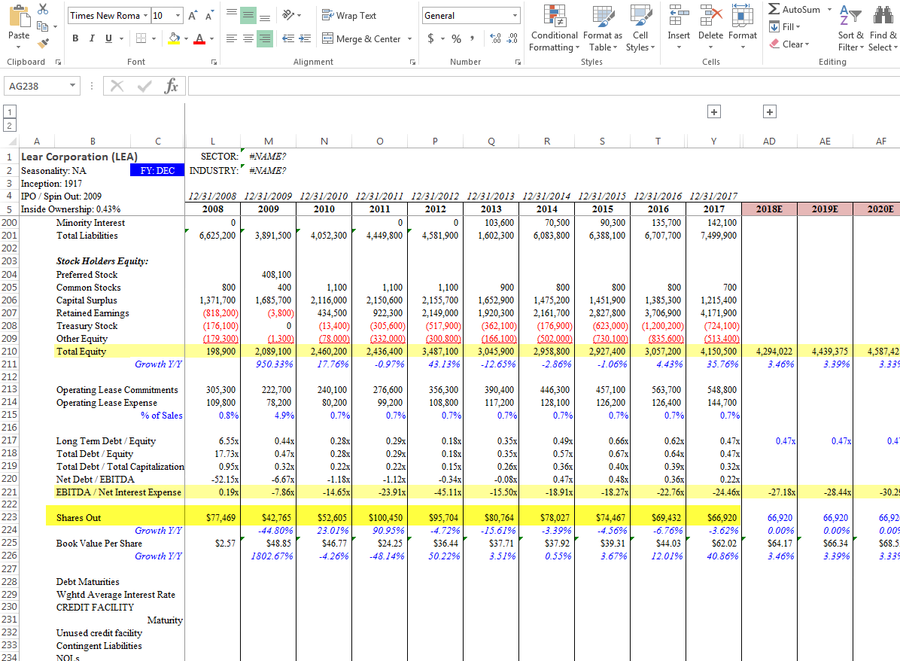
To enter the Employees count in the operating data, Search the 10-k form with the keyword Employee
Should be entered on the annual & quarter columns of shares outstanding which comes under Balance Sheet

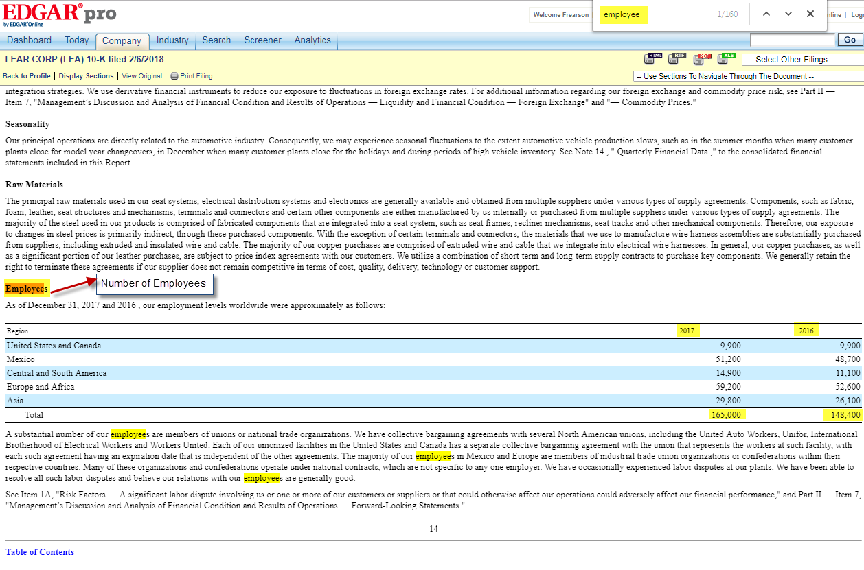
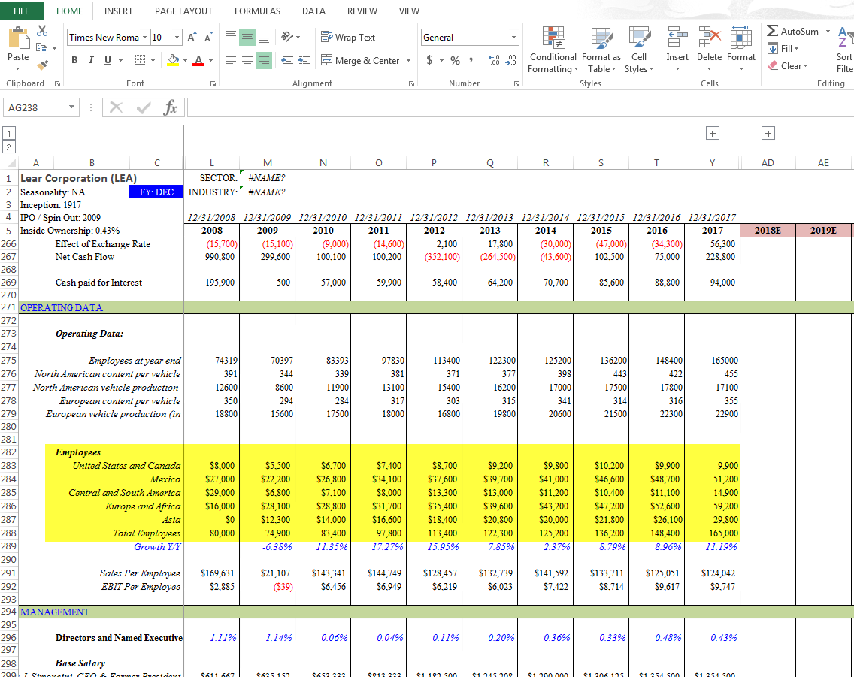
Check the stock based compensation with the keyword stock, it will comes under Cash Flow Operating Activities
Enter the employees count as given below

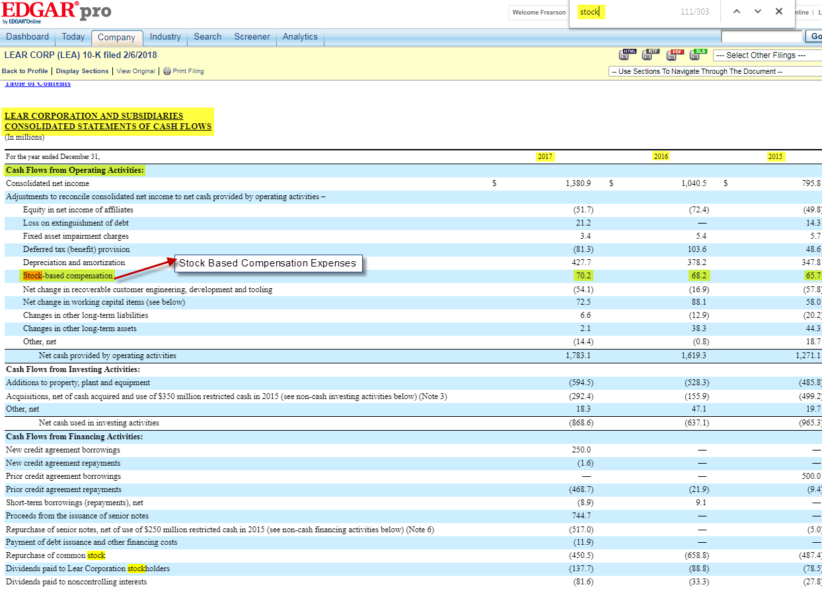
Stock Based Compensation Comes under Management as given below
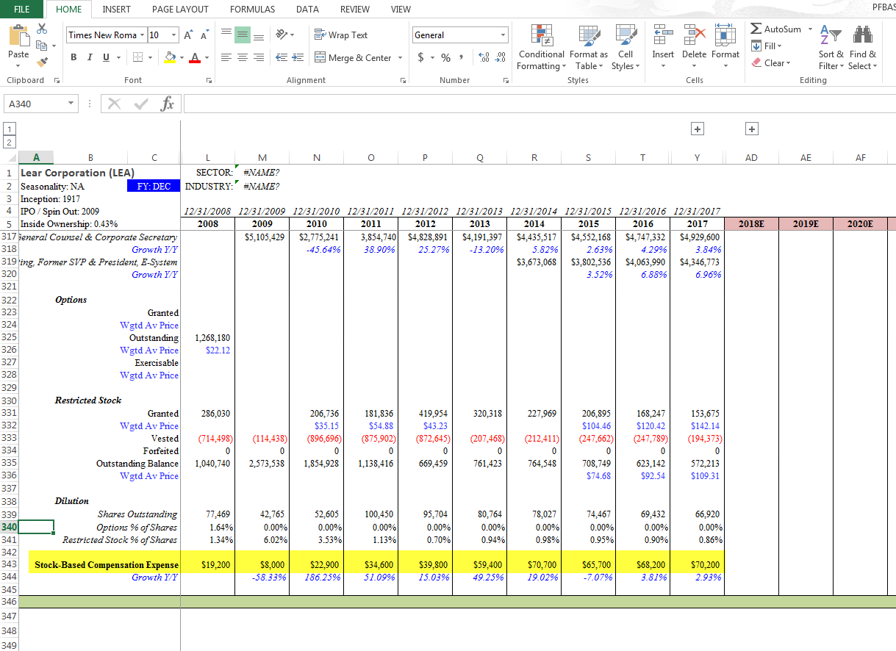
Acquisition will be given under the Cash Flow Investing Activities. Should be taken from 10k & 10q forms. Keyword: Acquired or Acquisition

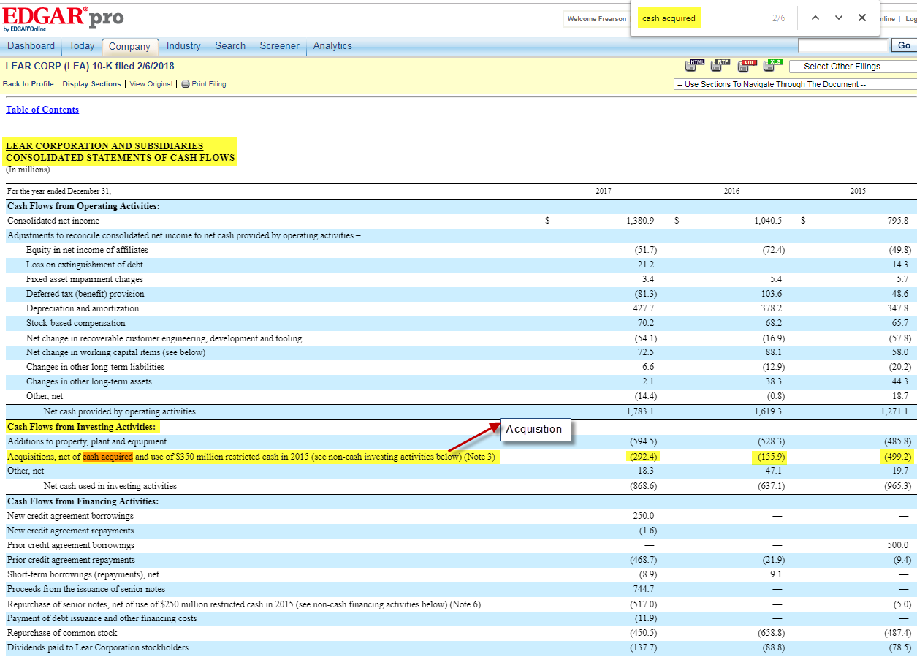
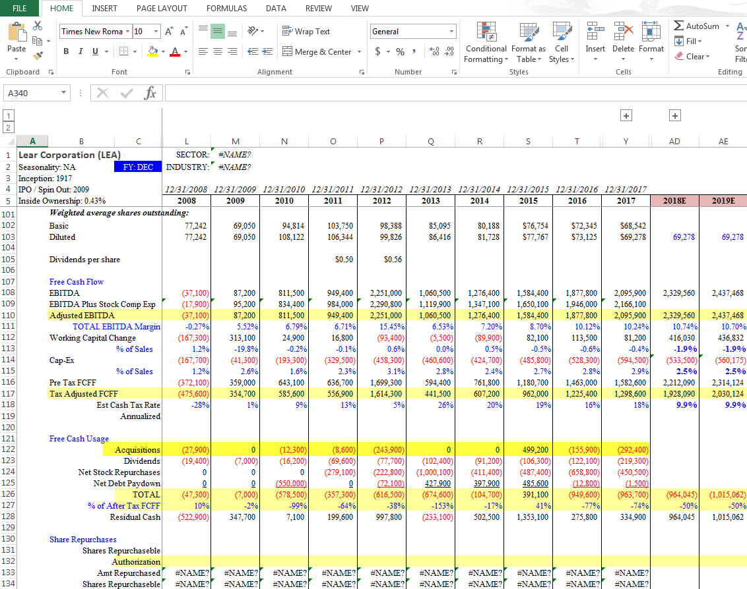
To search the Cash paid for interest & Cash paid for income tax, the keywords are: Paid, Paid for, Interest Paid. Should be taken from 10-K forms.
Should be entered as given below

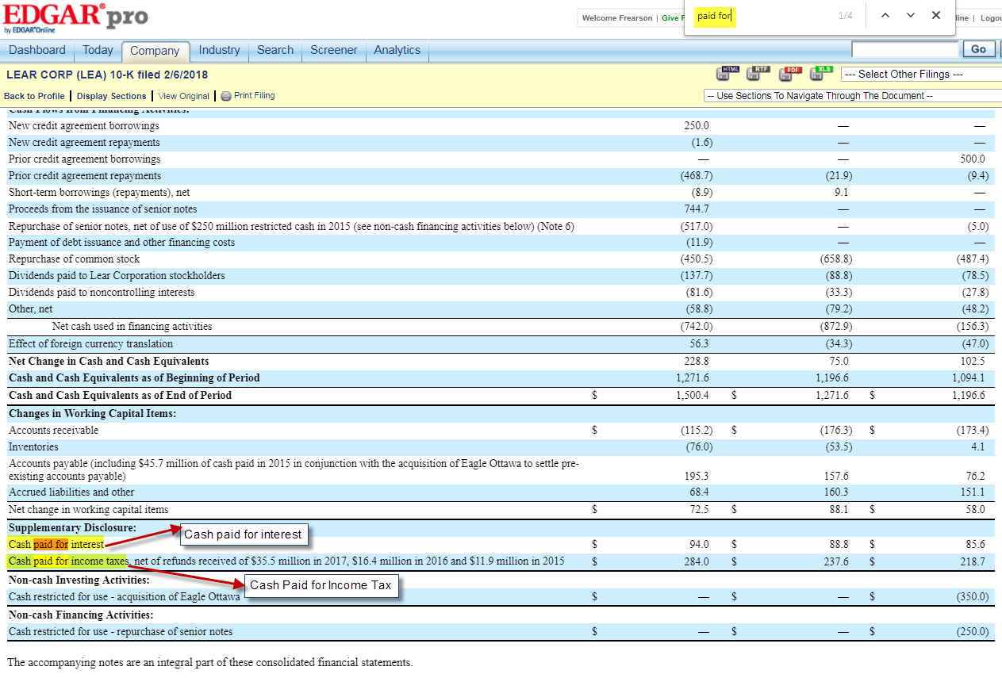
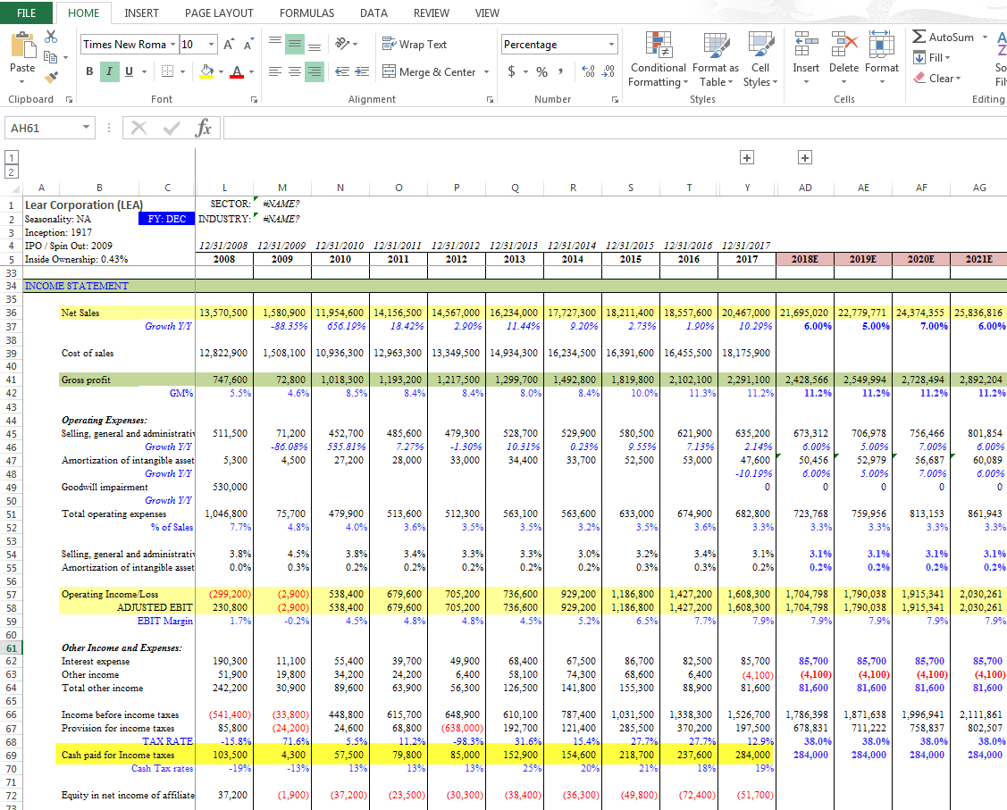
Cash paid for incomes taxes will comes under Income Statement & Cash paid for interest will comes under Cash Flow. As given below
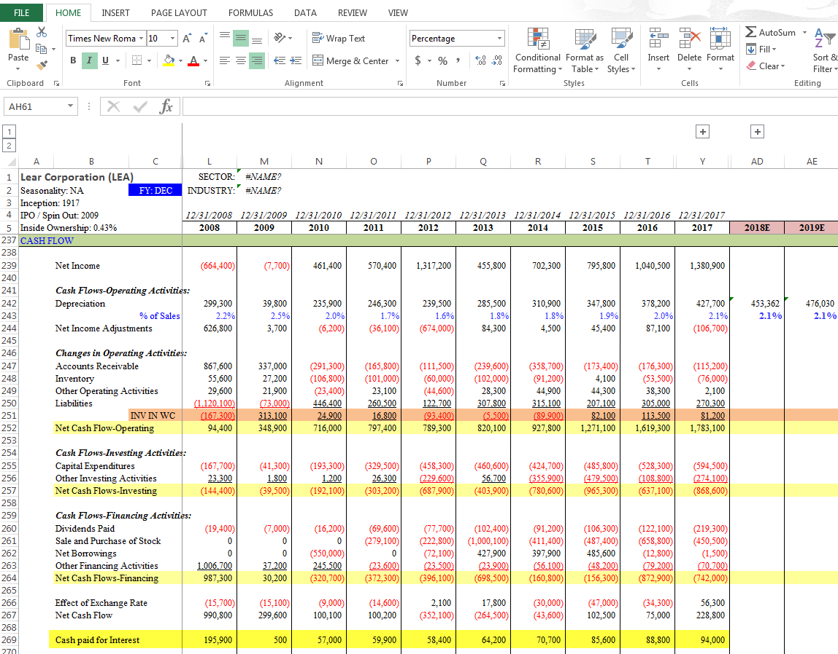

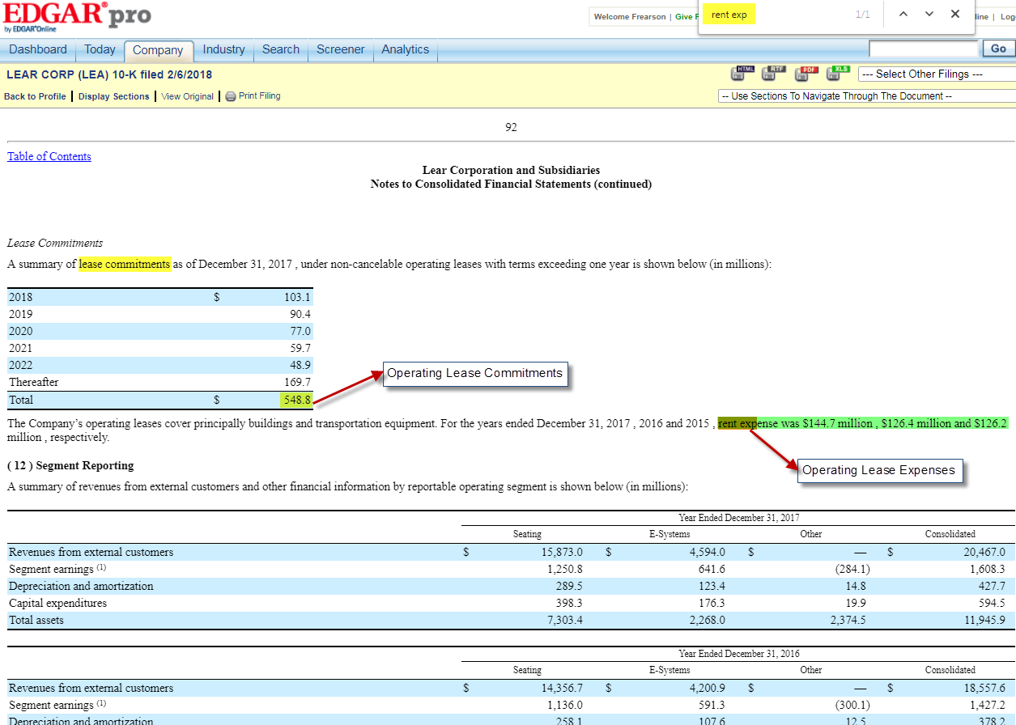
Operating Lease should be entered as given below. It will comes under Balance Sheet
To Search Operating lease expenses the keywords are: Rent expenses, Lease Expenses.
Operating Lease Commitments keyword: lease commitments. Should enter the values from all 10-k forms

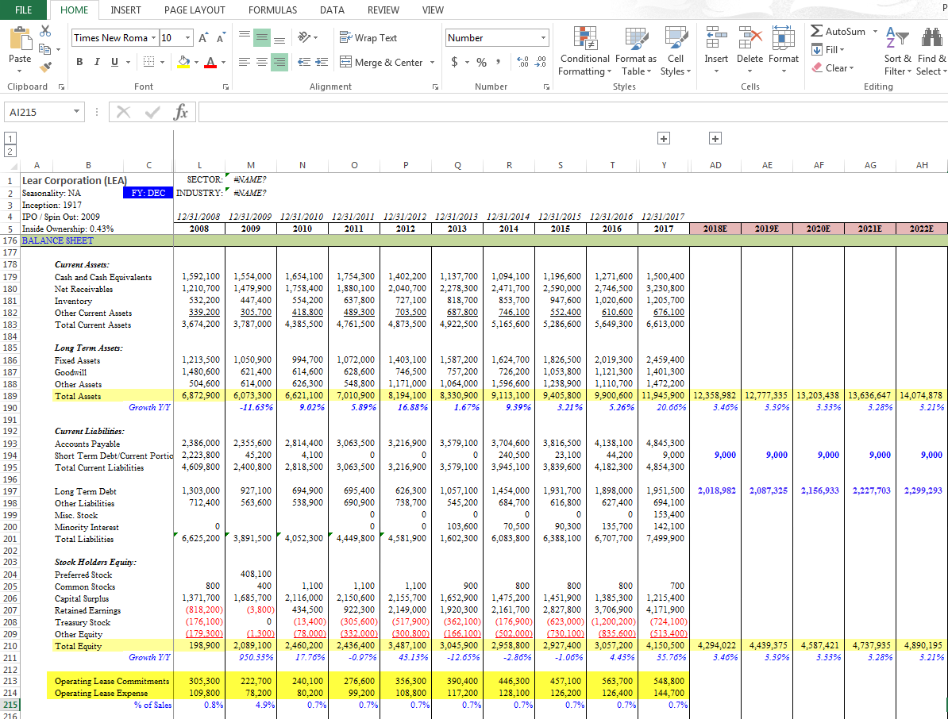
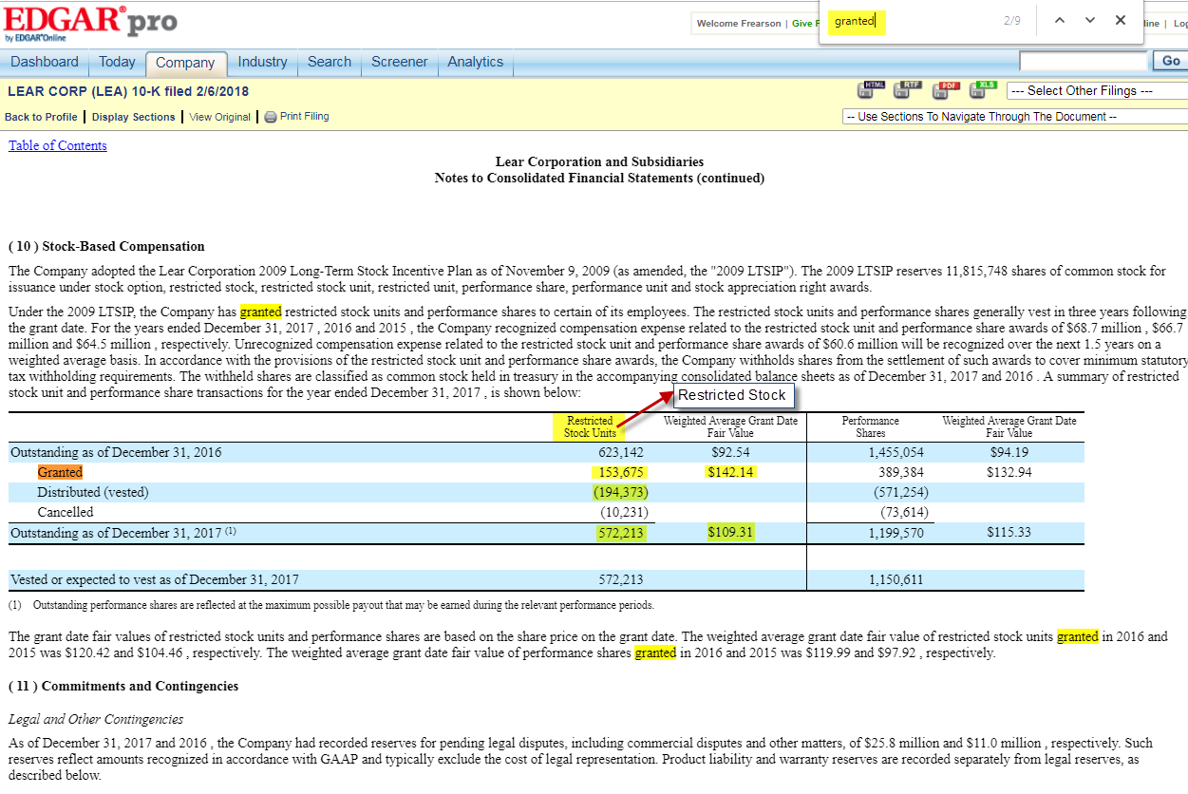
Restricted Stock option should be entered as given below
Restricted stock Keywords: Granted, Restricted Stock Unit, RSU. Should entered from all the 10-k forms

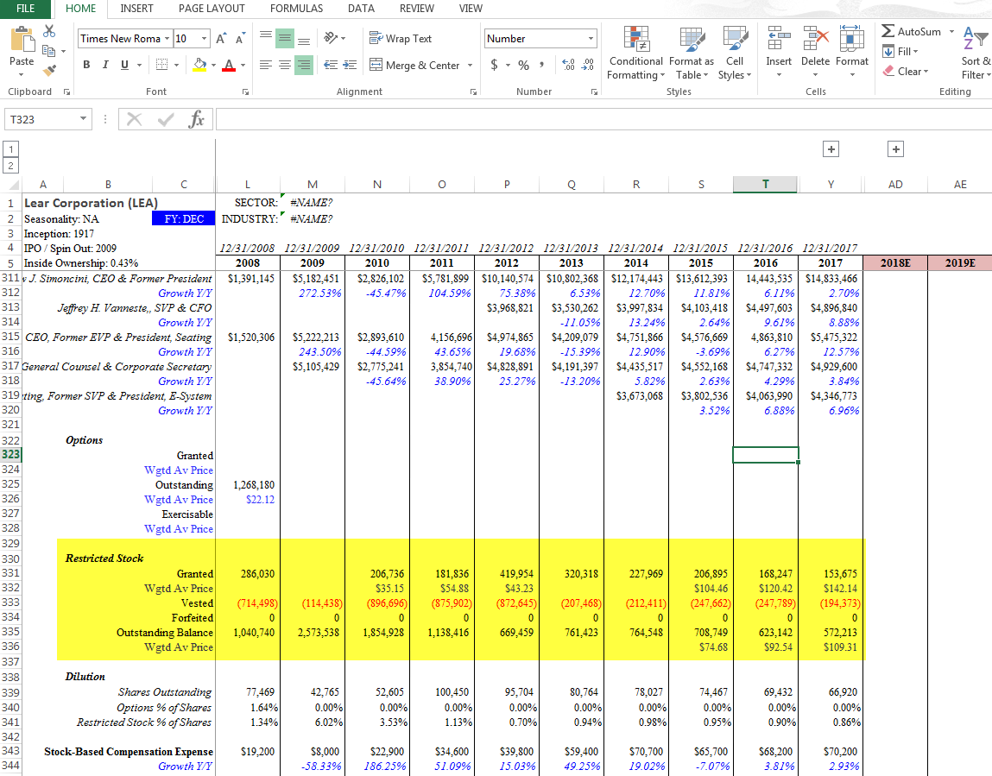
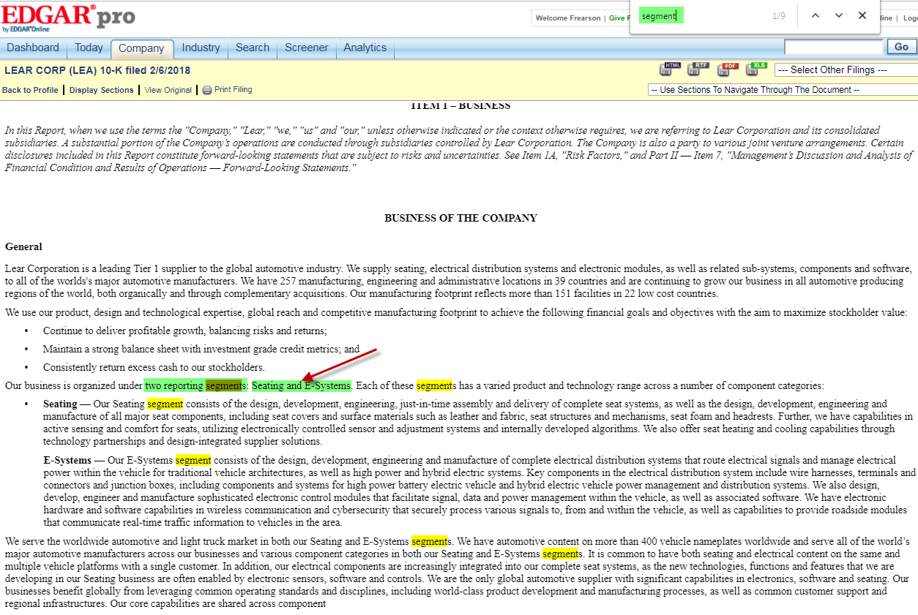
Revenues for the segments are given below. Revenues can find by searching with one of the segment name as keyword
Segments should enter from all the 10-k & 10-q forms. Keyword: Segment. No need to enter the segment values, if it is mentioned as one-reportable segment. This company organized under 2 reportable segment. Seating & E-System

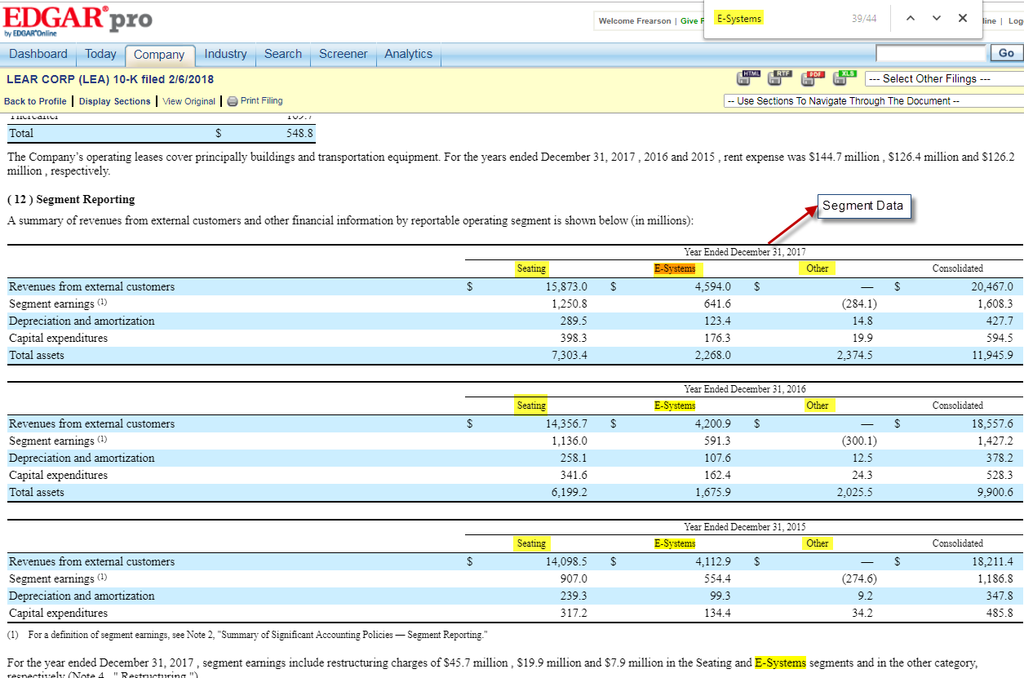
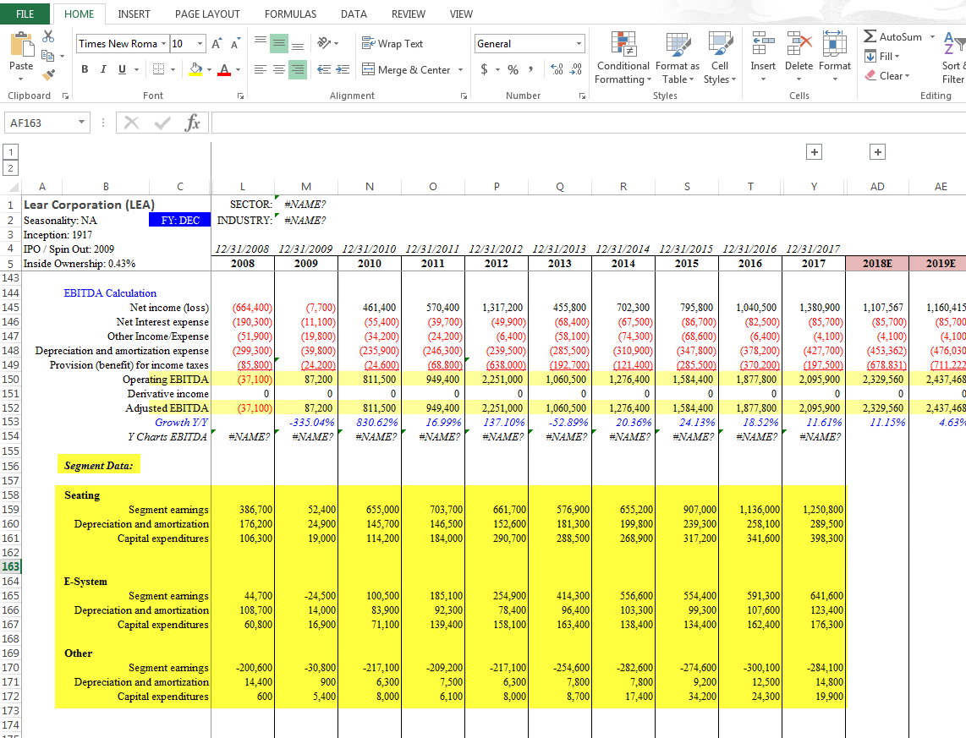
To enter the quarterly values, Click the All Quarterly Filings & open the last 6 forms which consists of 1^{st,} 2nd & 3rd quarter values
Segment data should be entered as given below

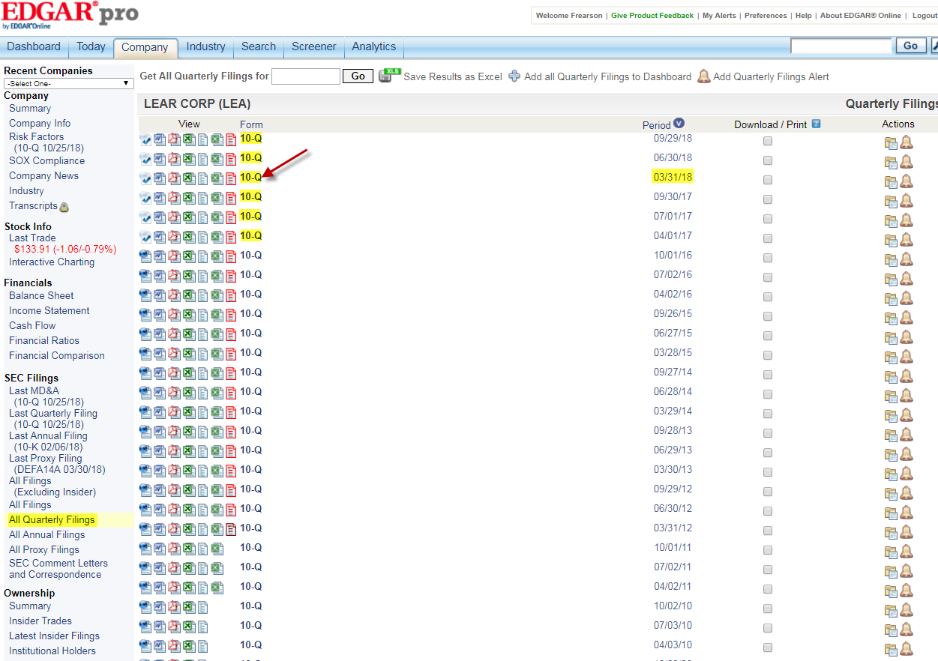
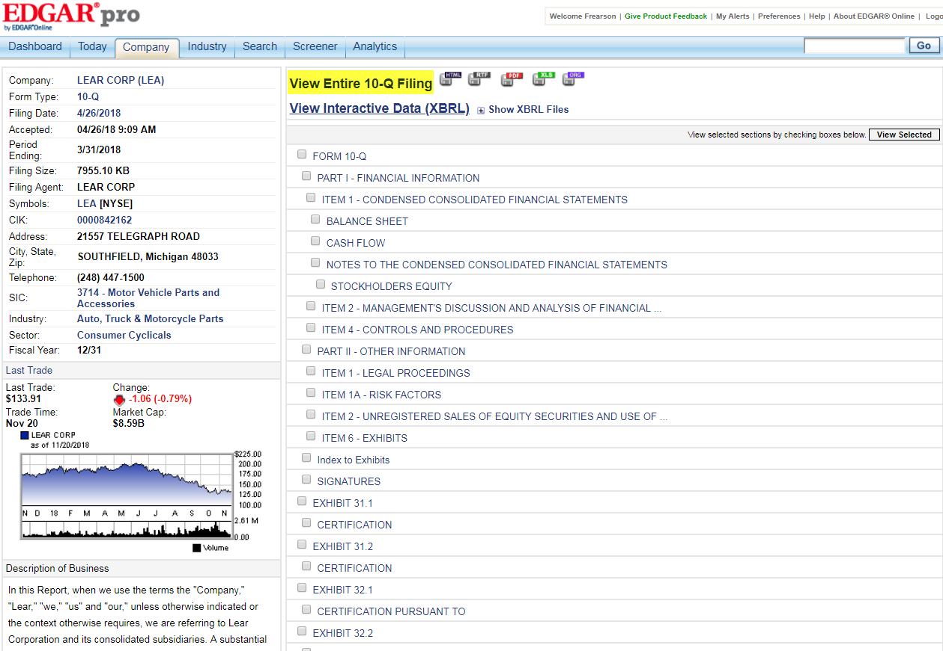
Click on the View Entire 10-Q Filings
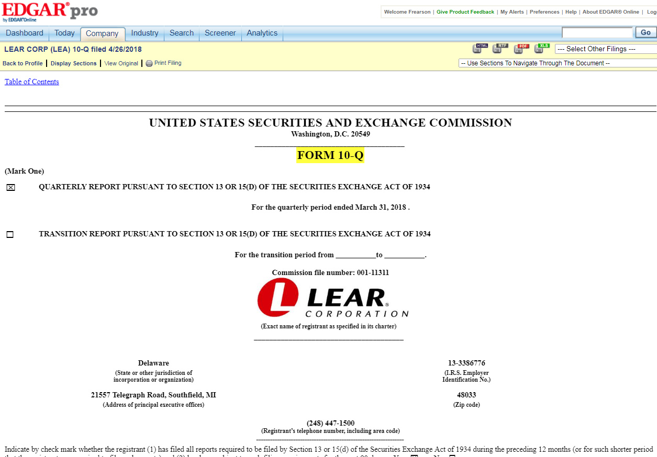
Like 10-K form, shares outstanding will appear on the 1st page of the 10-Q form
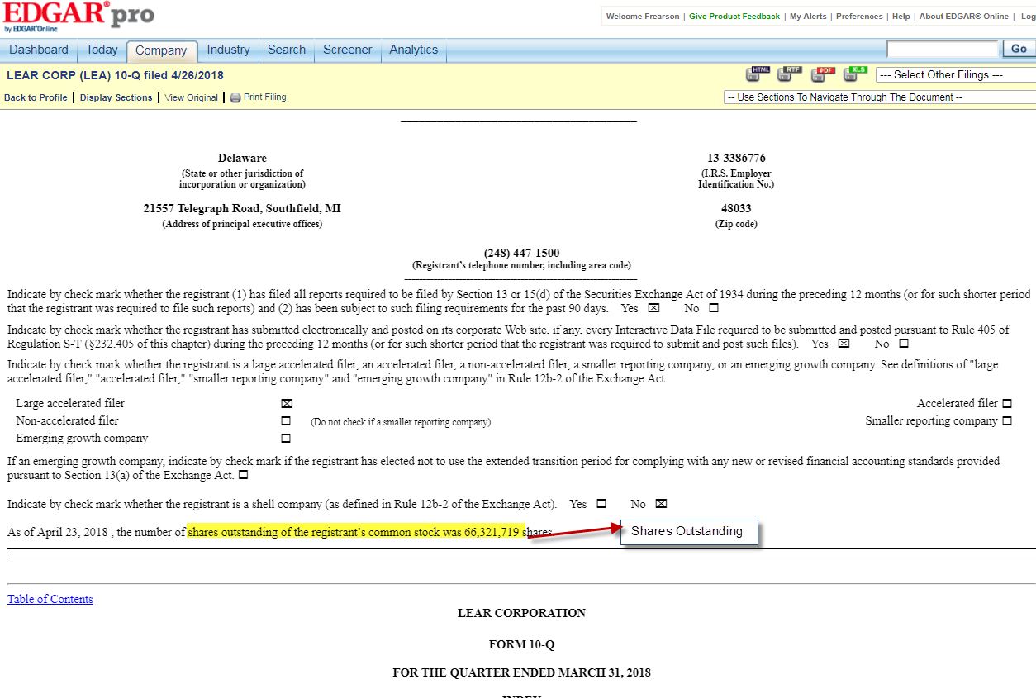
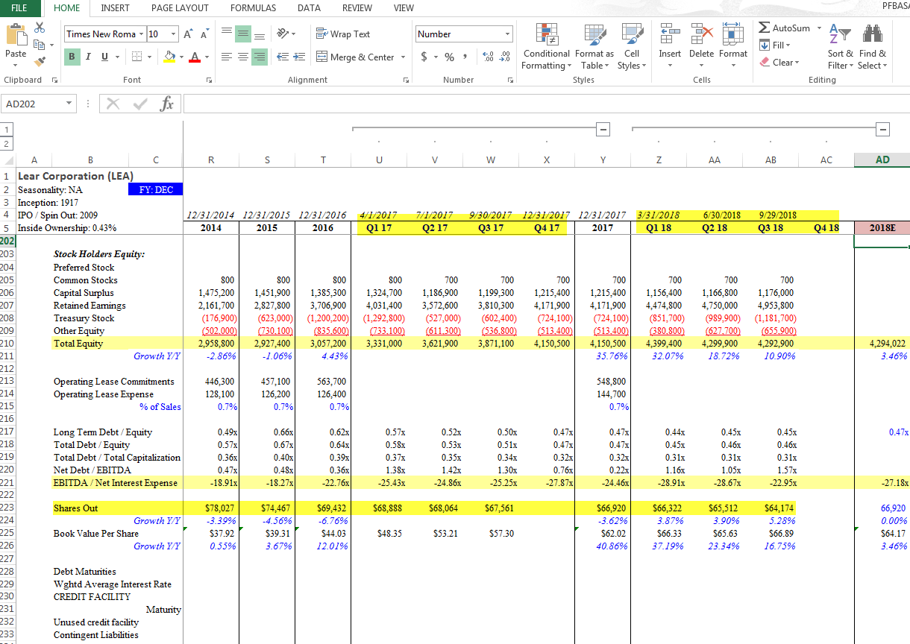
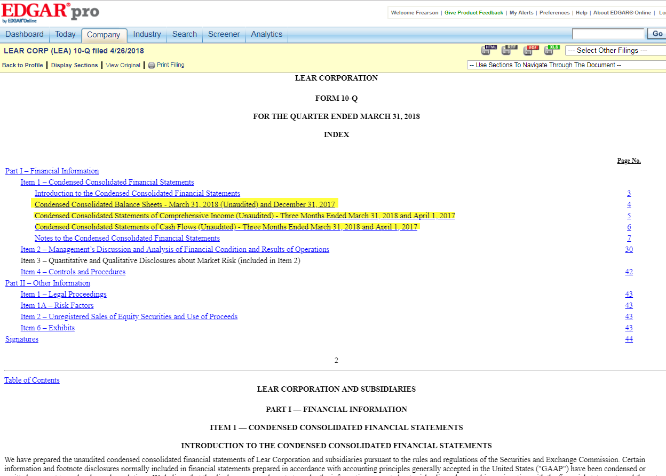
The below values are given for the 1st quarter of 2017 & 2018. To enter the 2nd & 3rd quarter values, open the rest of the 10-Q form
Scroll the page and select the consolidated balance sheet to enter the quarter values

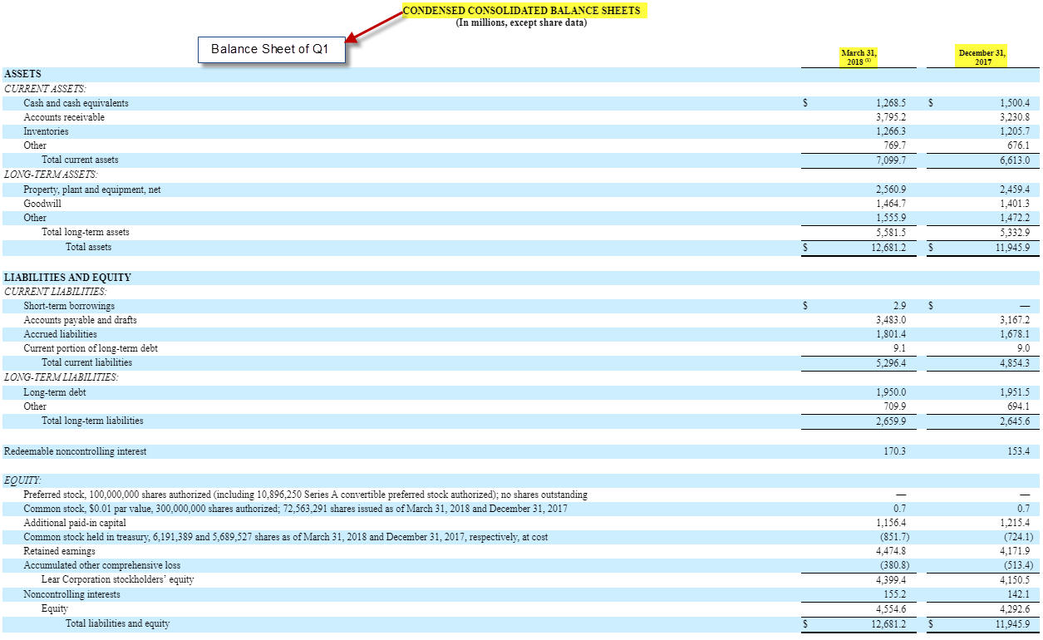
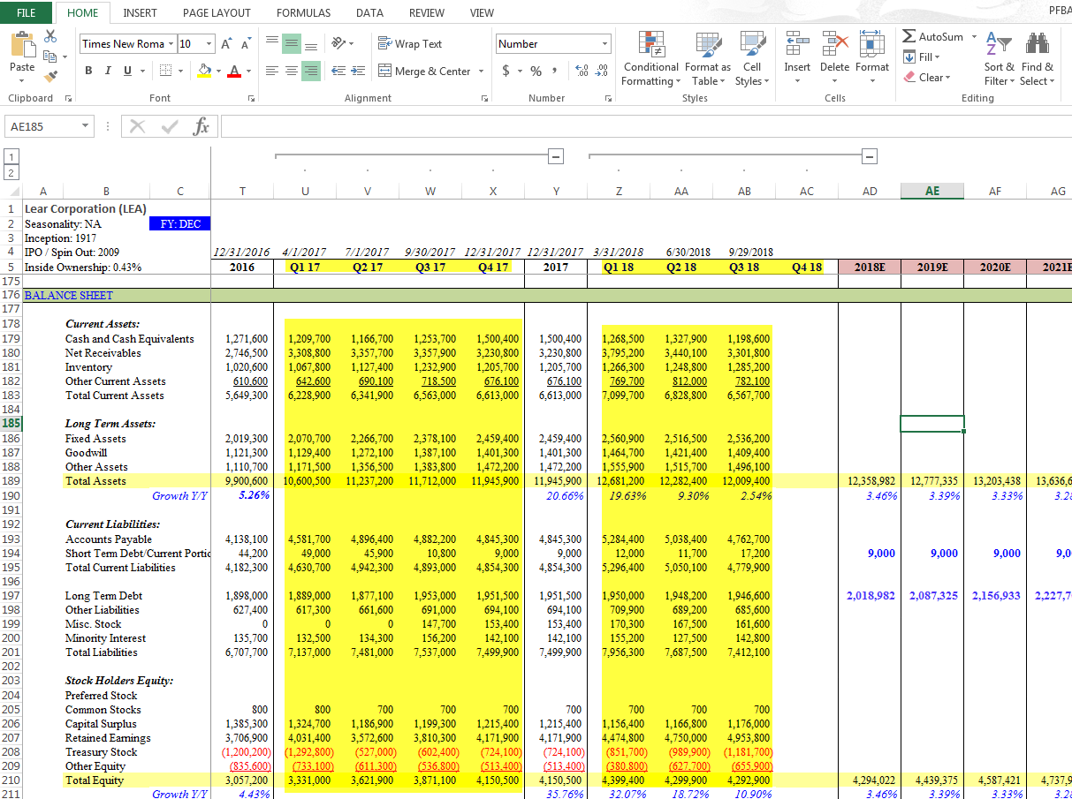
1st quarter values of Income Statement. To be entered in the 1st quarter
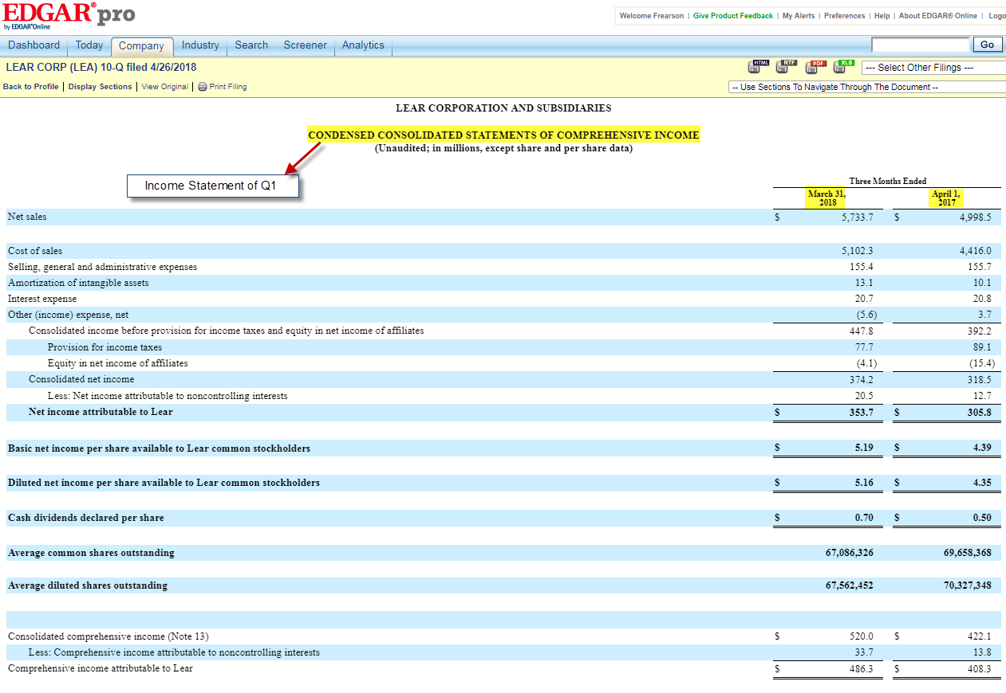
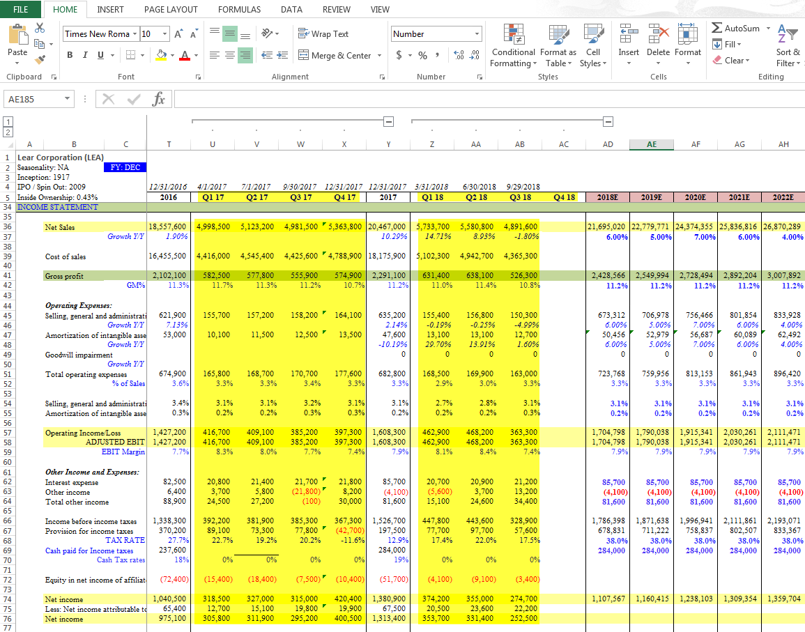
1ST Quarter values of Cash flow are given as consolidated cash flow. And it should be entered in the quarter values
Income Statement quarter values should be entered as given below

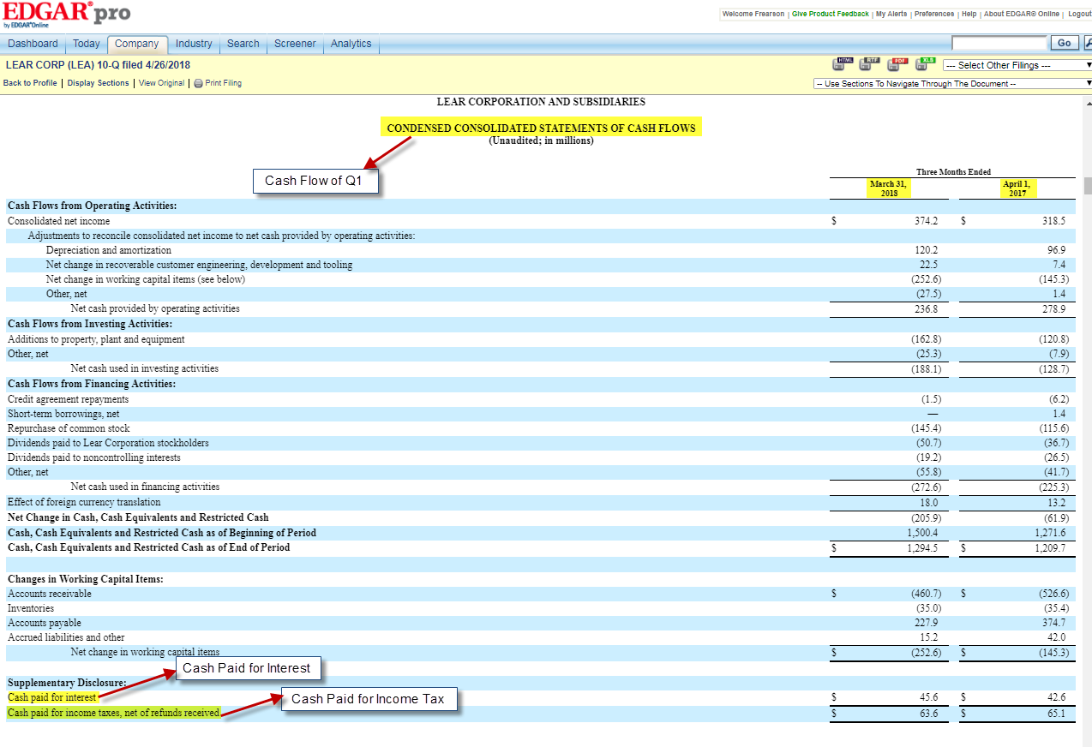

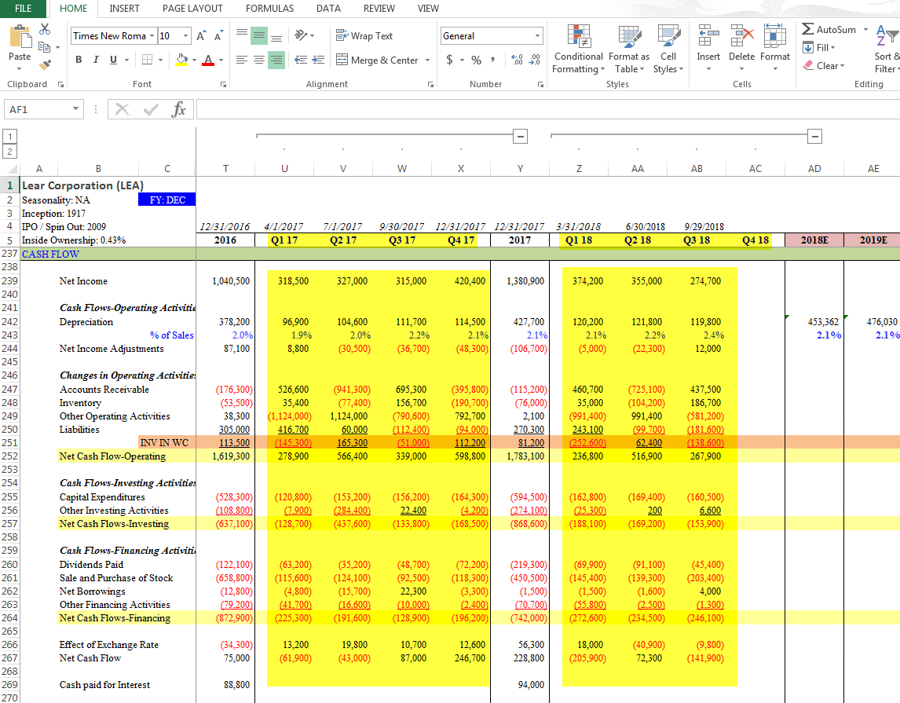
Segments at quarterly form are given as same as the 10-k form. Enter the Segment quarterly Values
Quarterly Values of cash flow should be entered as given below

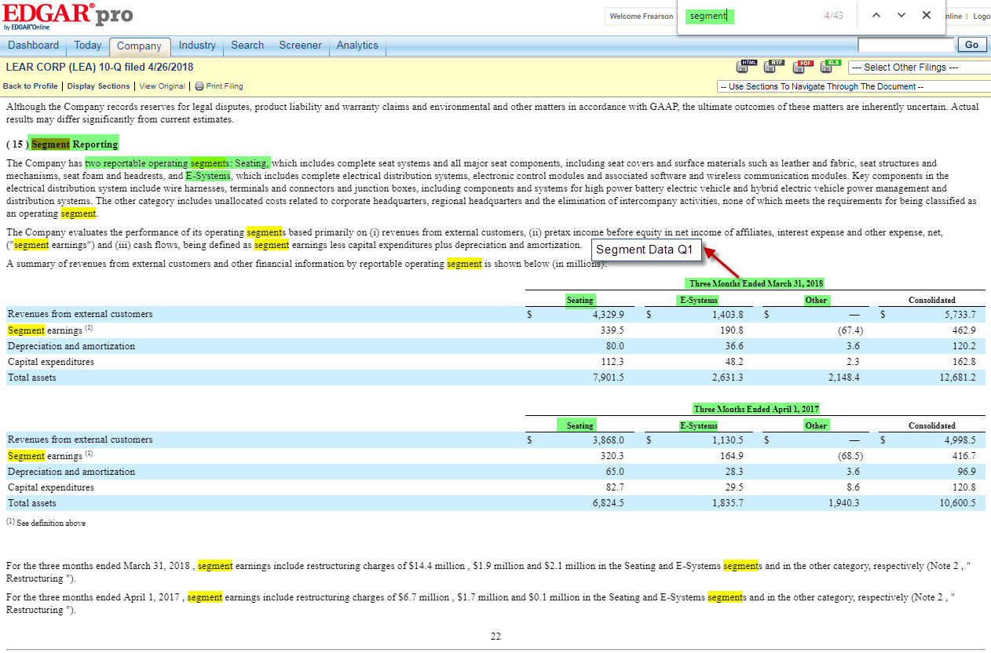
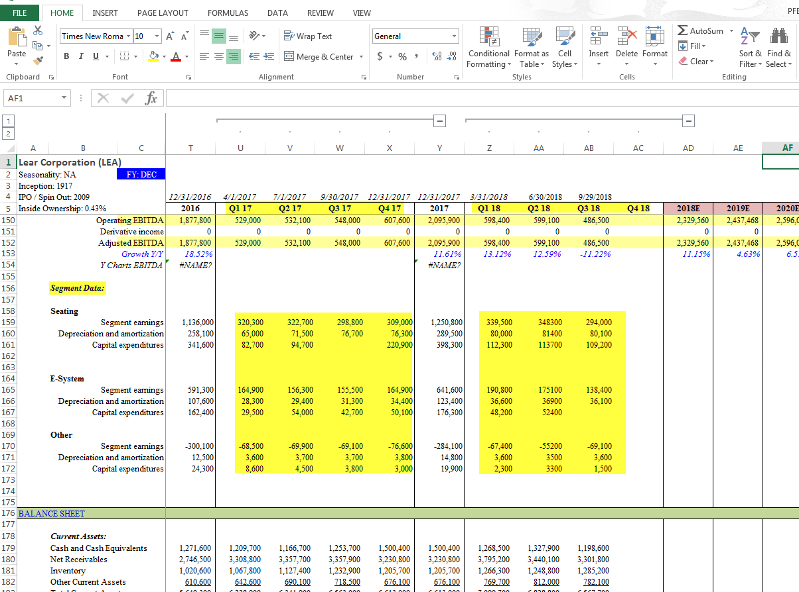
Segment values should be entered as given below
To fill the management details, Select All proxy Filings & open all the DEF14A forms which contains the details of salary & ownership percentage

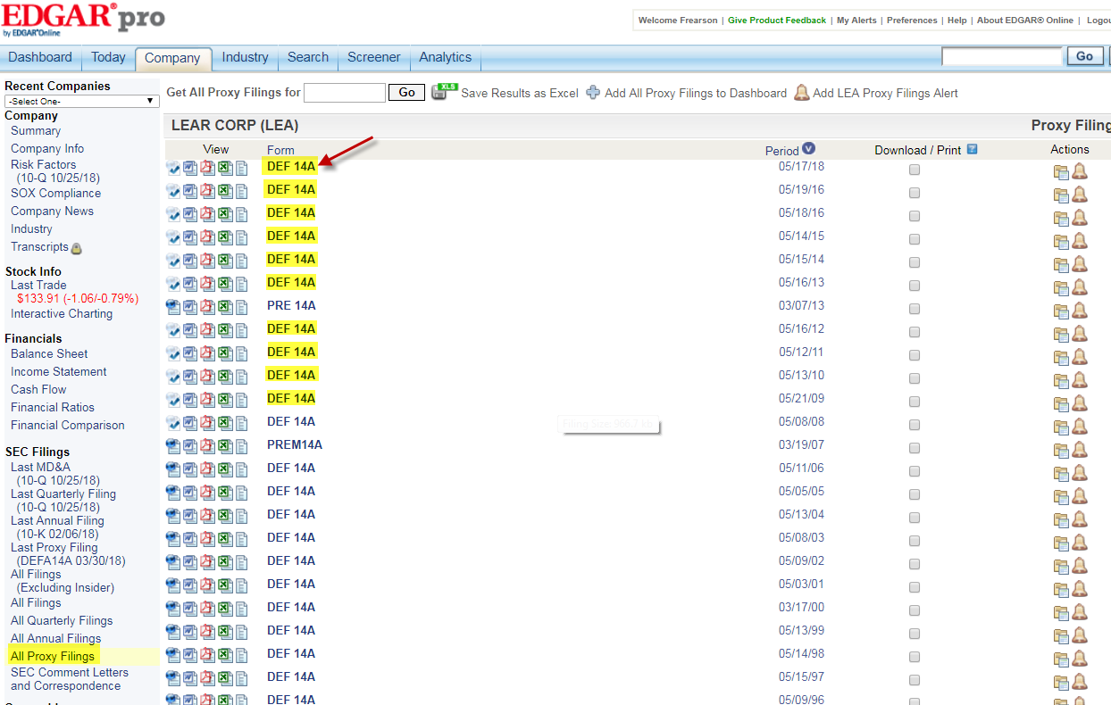
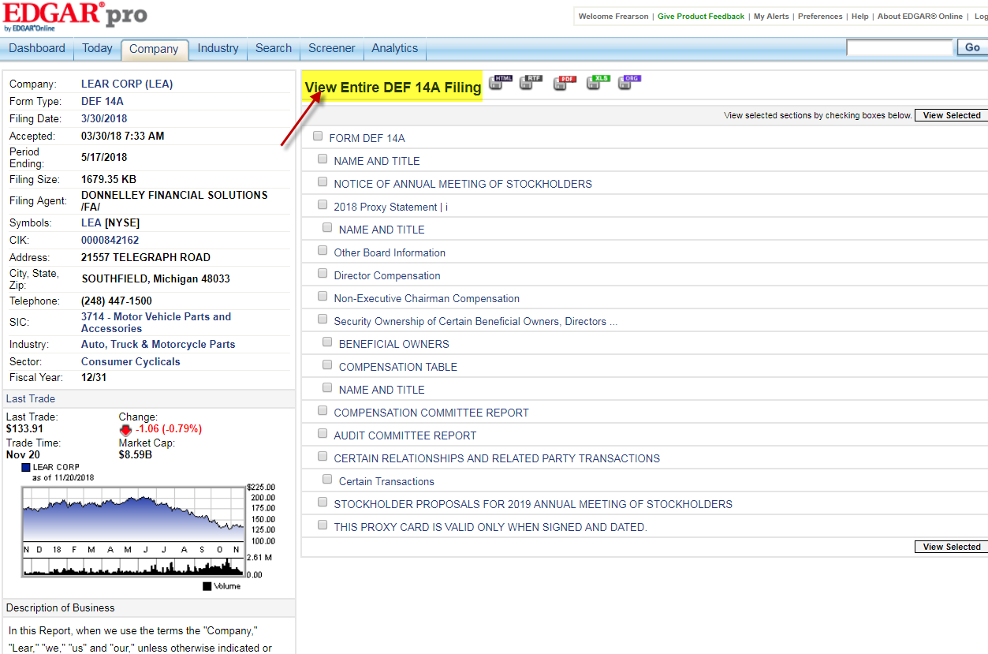
Click on the View Entire DEF 14A Filings

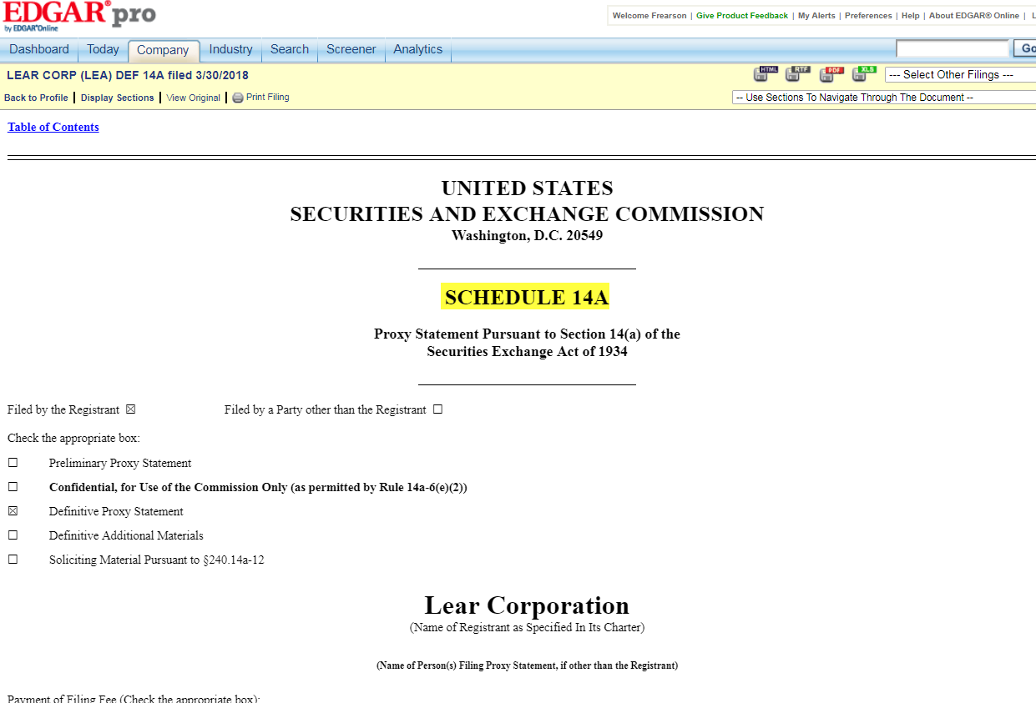
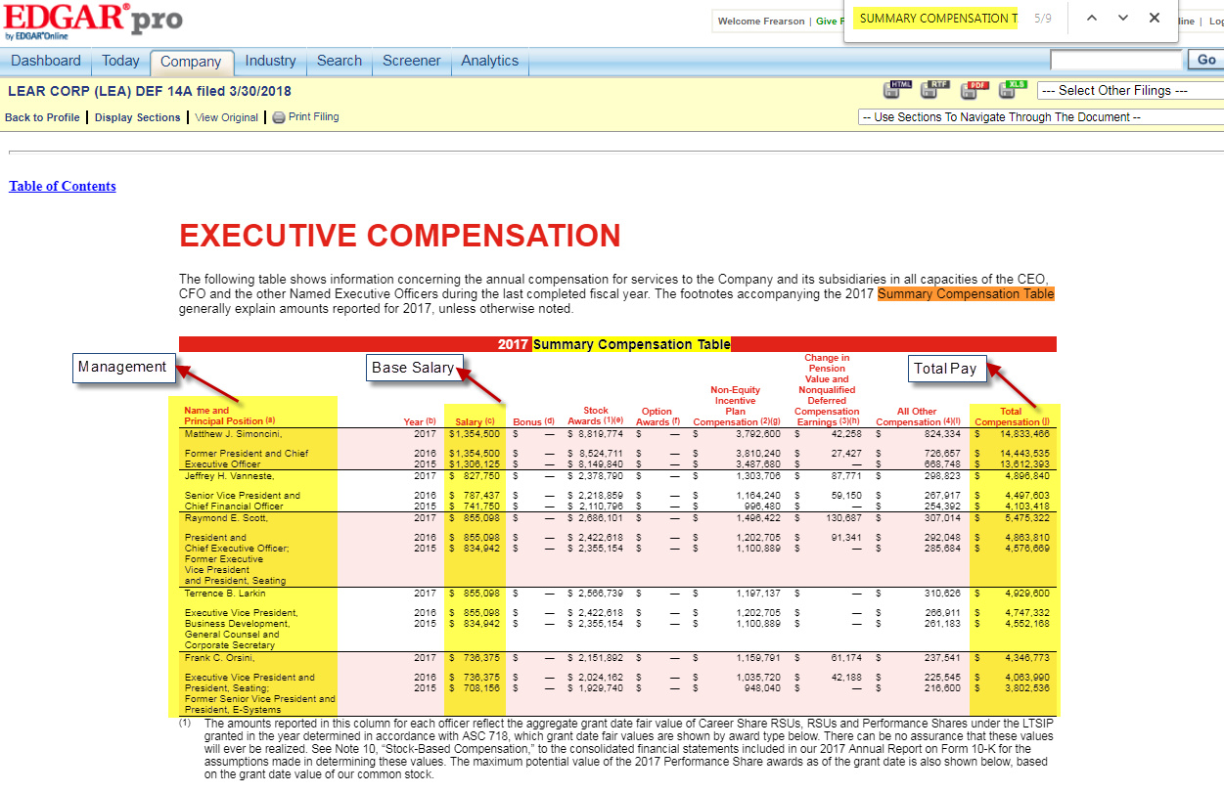
Management details should be entered as given below
Search the keyword as Summary Compensation Table to get the salary details as given below. Need to take the Officers Names, Base Salary & Total Pay for last 10 years. Officer’s name should be taken from the recent form

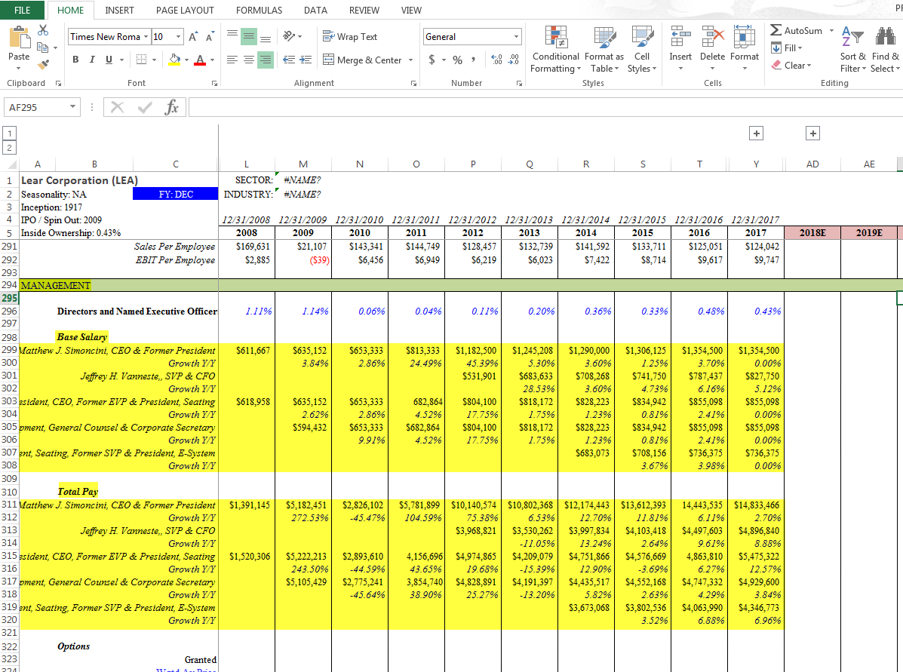
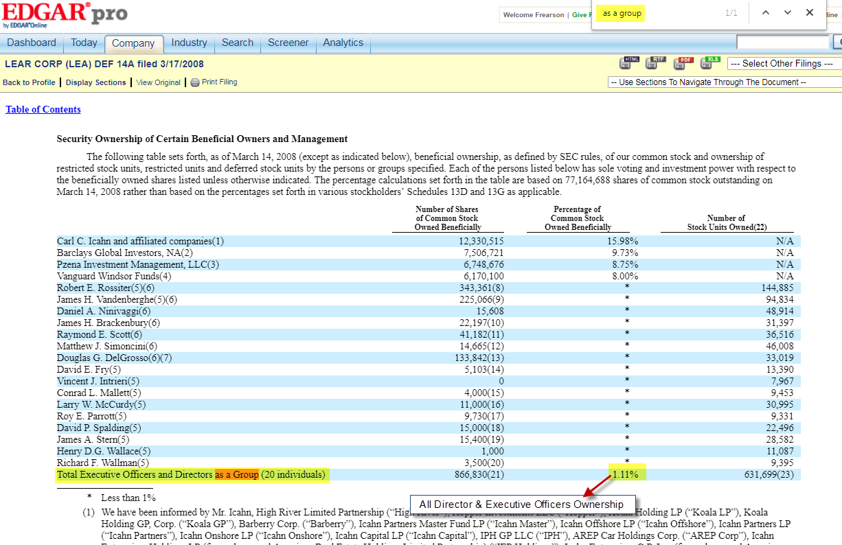
Percentage should be entered in the management as given below
To Search the Directors & Executive Officer Ownership, the keyword is: as a group.
It should be entered in the Management

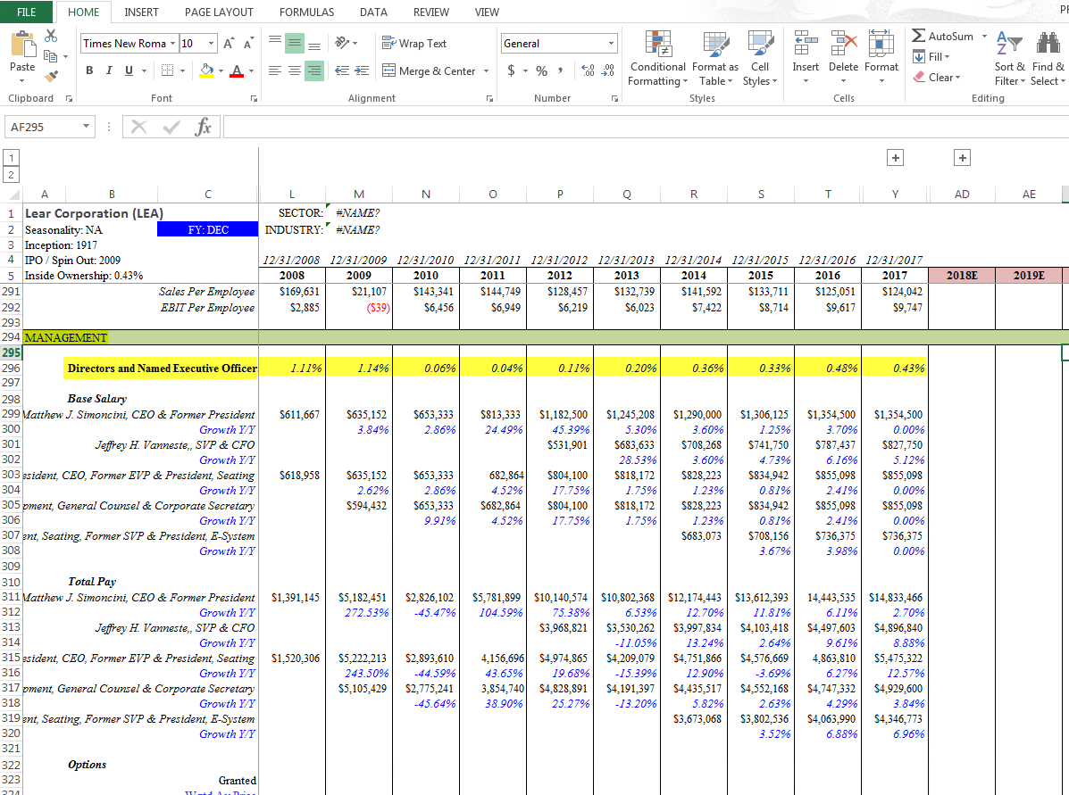
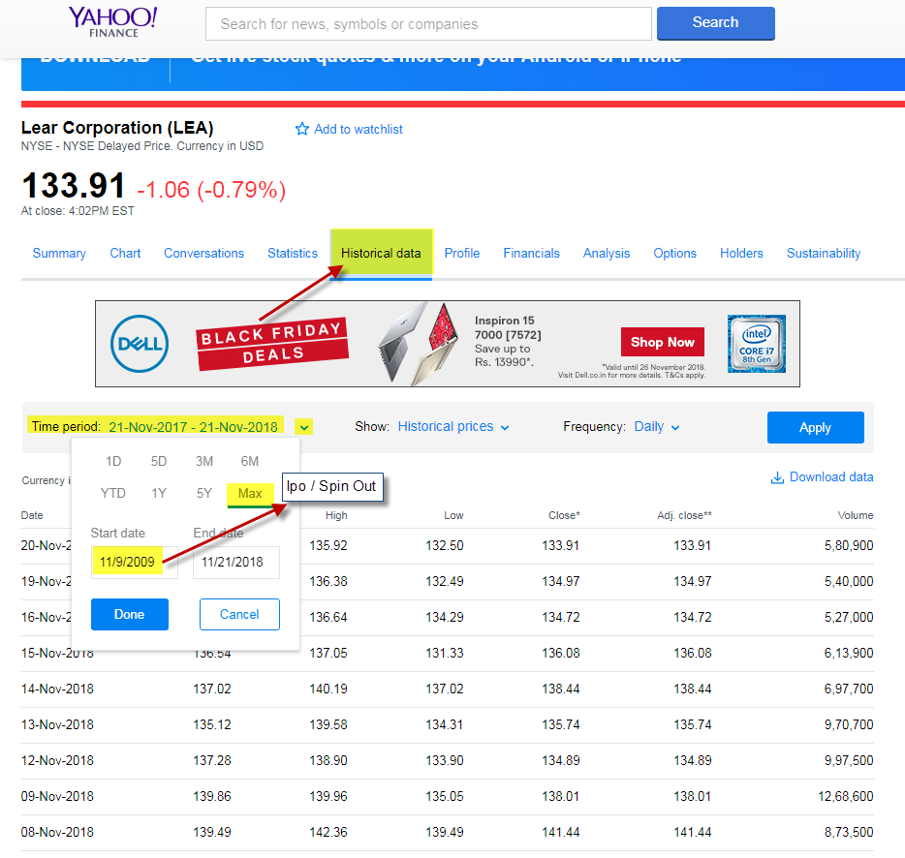
To take the average stock price. Go to yahoo finance, select the Historical Data & click the drop down at Time Period and Select max, the year given at the start date will be changed, and the changed year is the IPO/Spin out Year. And click Done
Now change the frequency from daily to Monthly

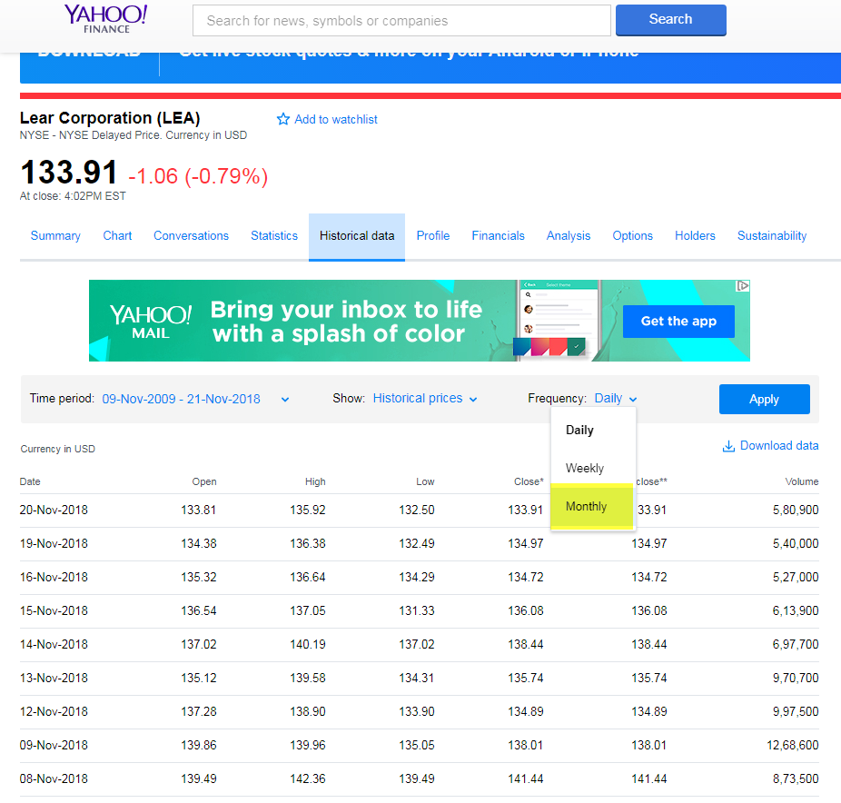
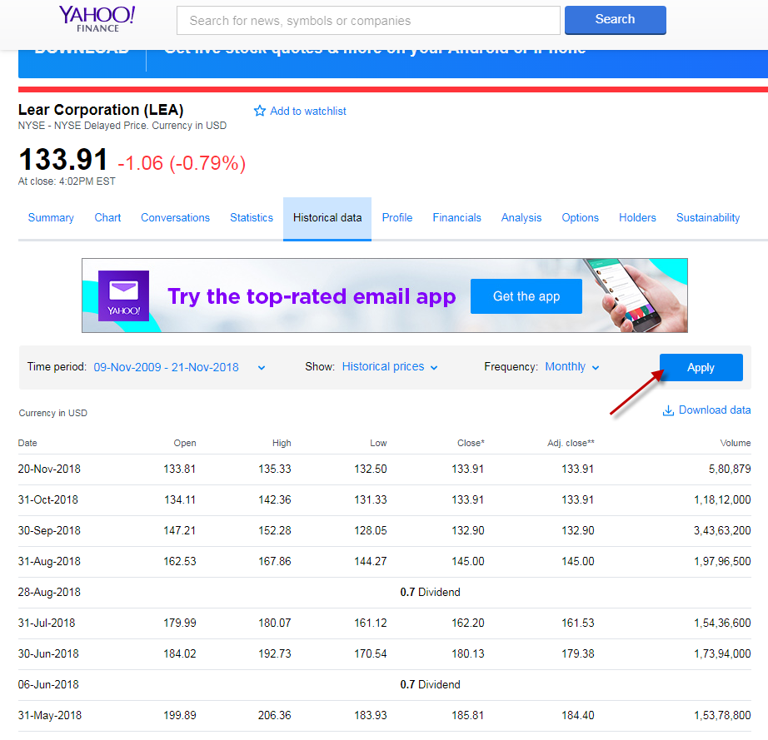
Download the data. The excel will be saved in the system
Give Apply

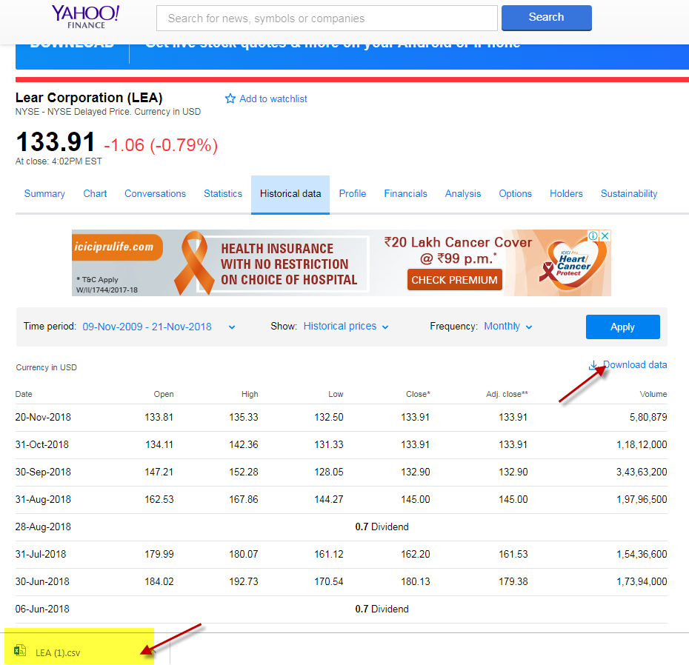
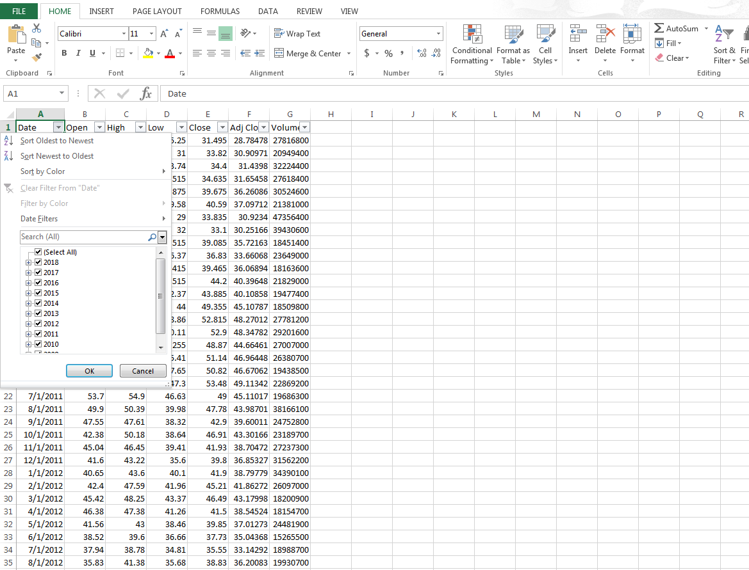
After clicking that, the excel will be opened like the below excel
Click on the drop down and select the year one by one and take the average of close value, by selecting the close value for the respective year. The average will appear at down of the excel as given below

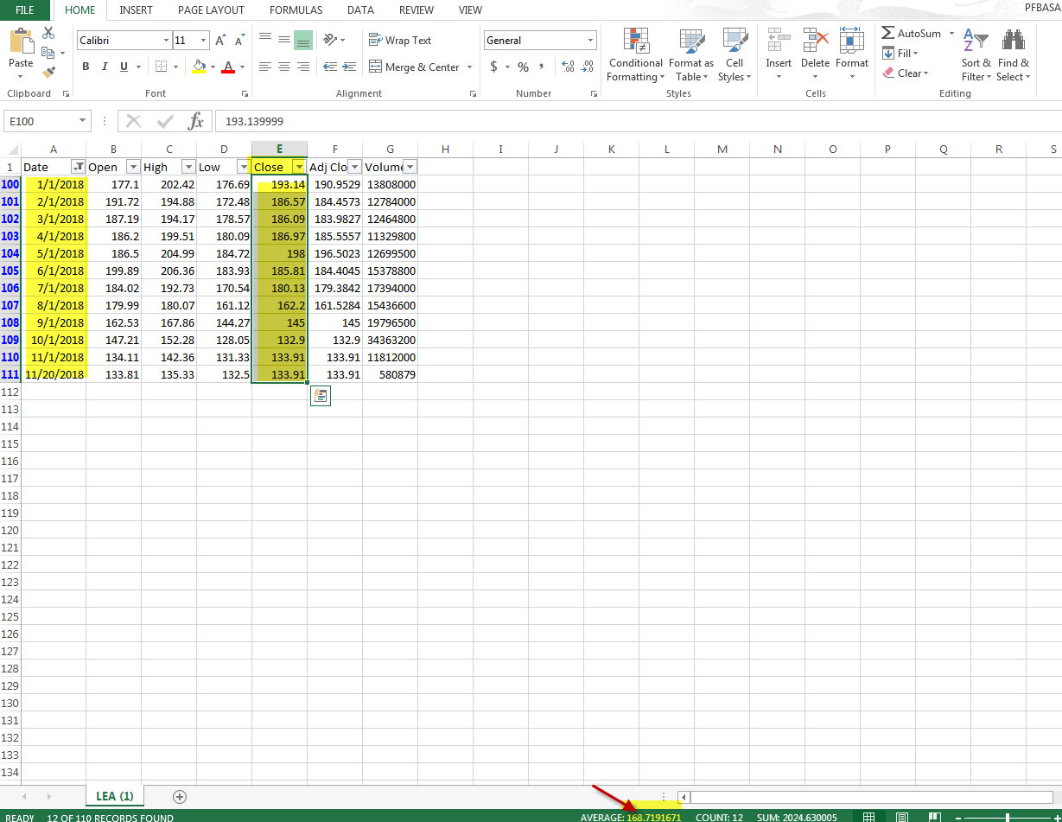
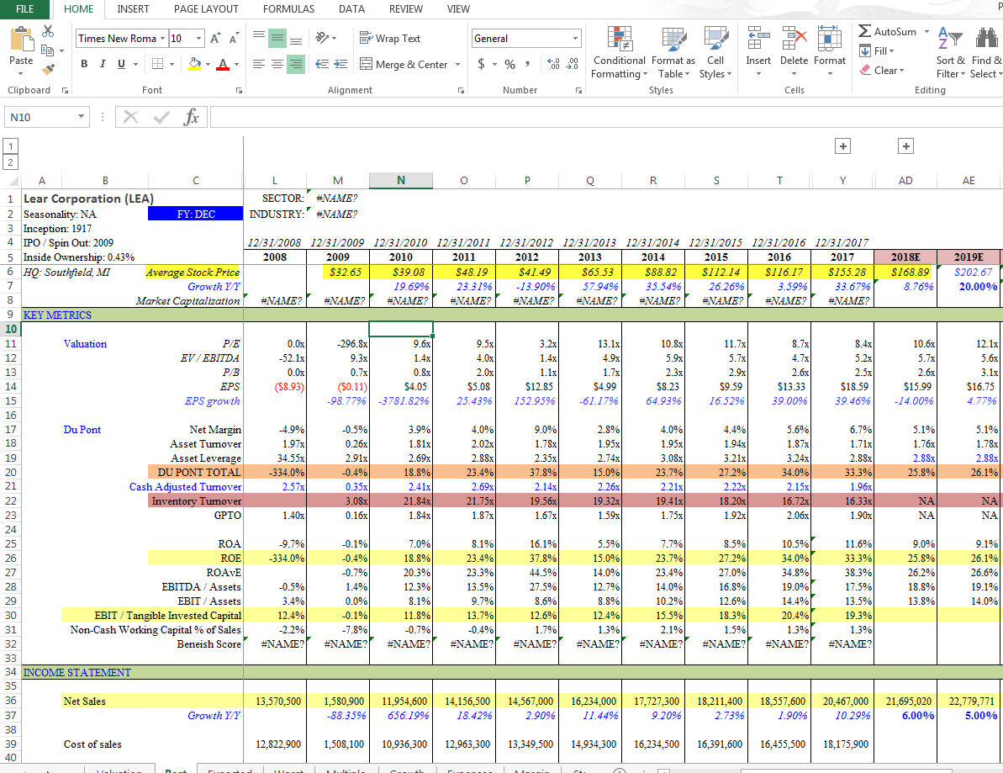
To take the total revenue for forecasting years, go to yahoo finance, select analysis, Avg. Estimate is the total revenue of Expected sheet, Low Estimate is the forecasting total revenue for Worst sheet, and high Estimate is the total revenue of Best Sheet
Average stock price should be taken from 2008-2018 by using the excel given above

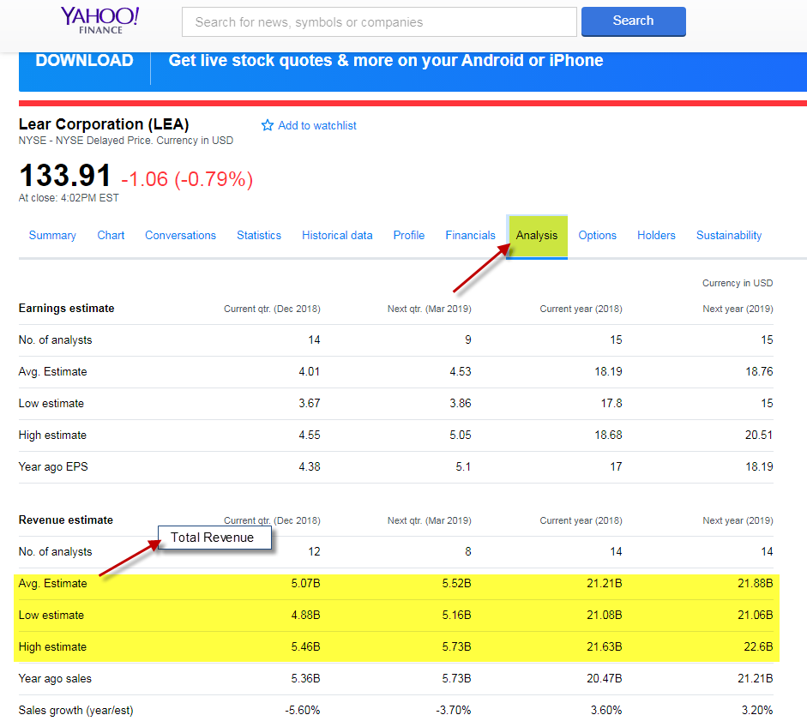
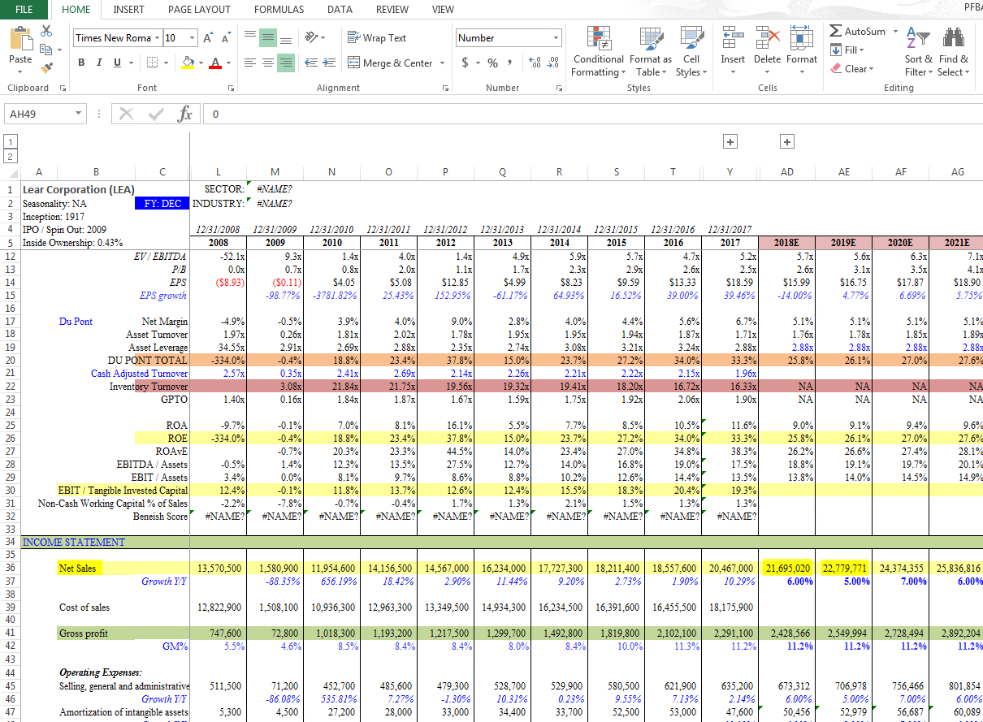
Total Revenue should be entered as given below
Go to Statista to check the shares outstanding, which has to be entered in the valuation sheet.
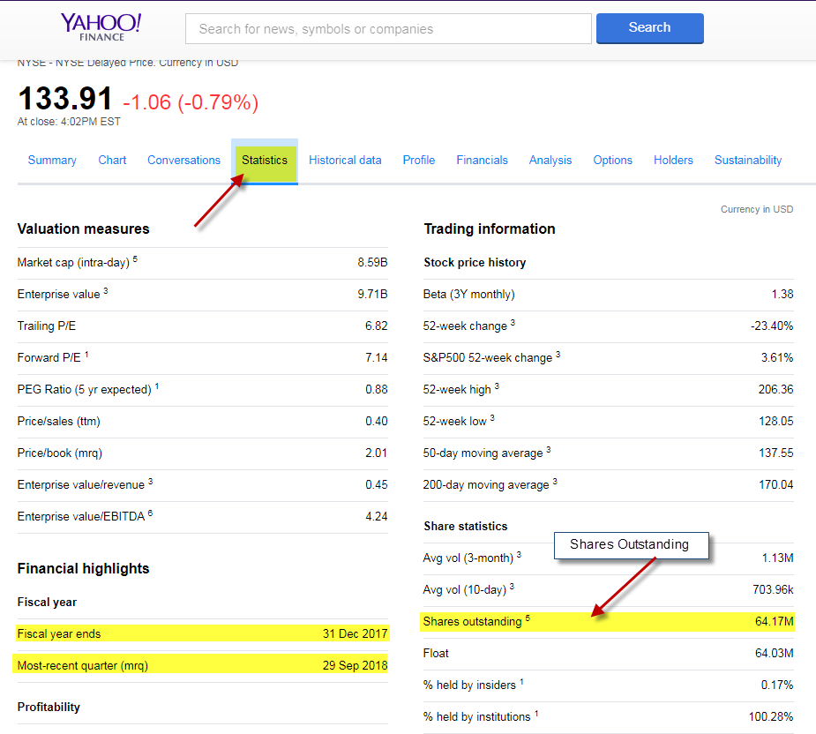
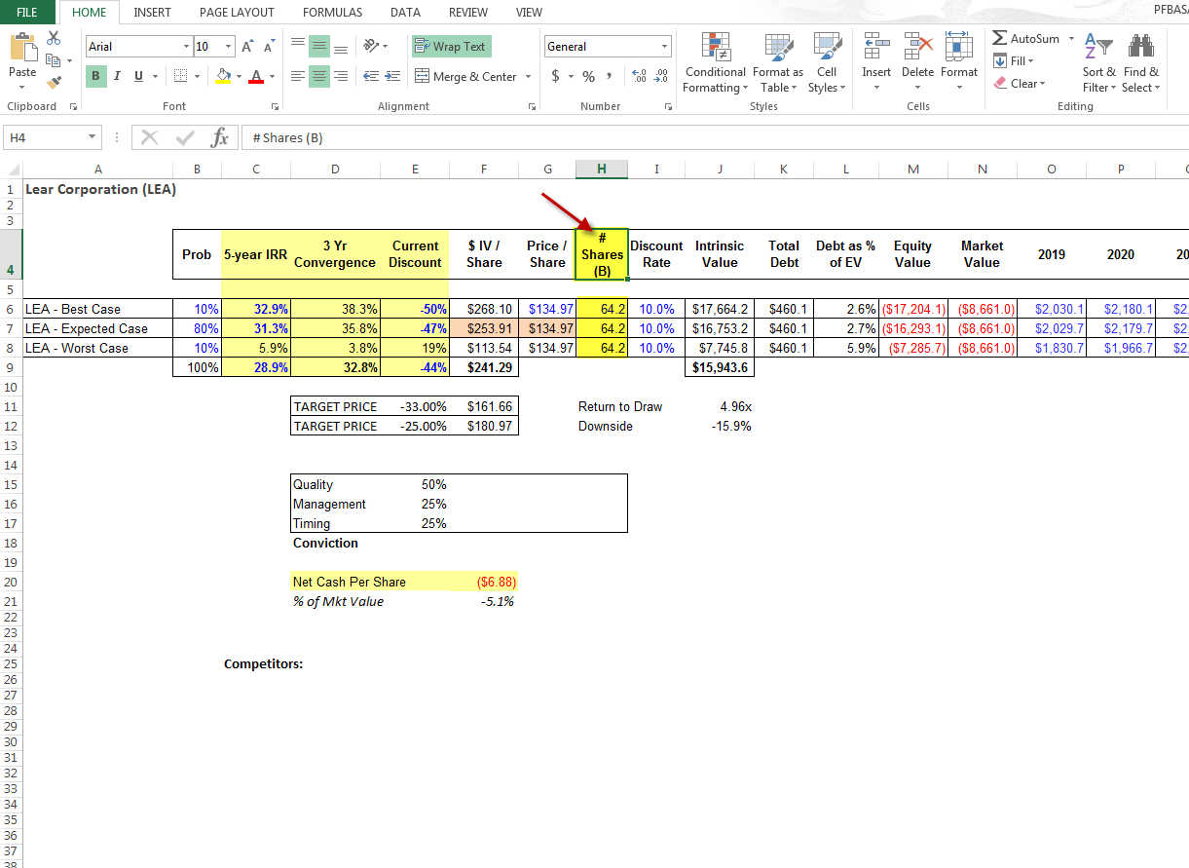
Here Shares (B) is the shares outstanding. It should be entered as given below
Price per share will be given at the top corner in yahoo finance. It will change by daily basis. It should be entered on the Valuation sheet. This industry type will used to take the Statista data

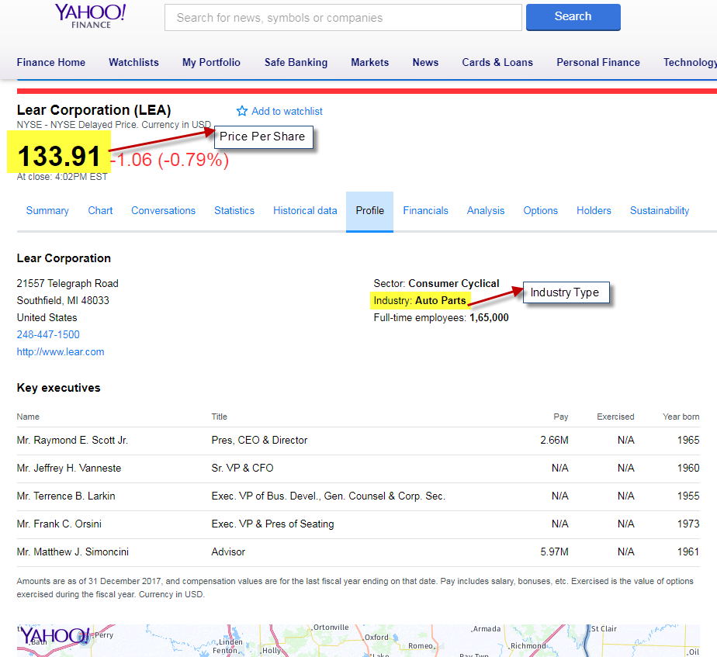
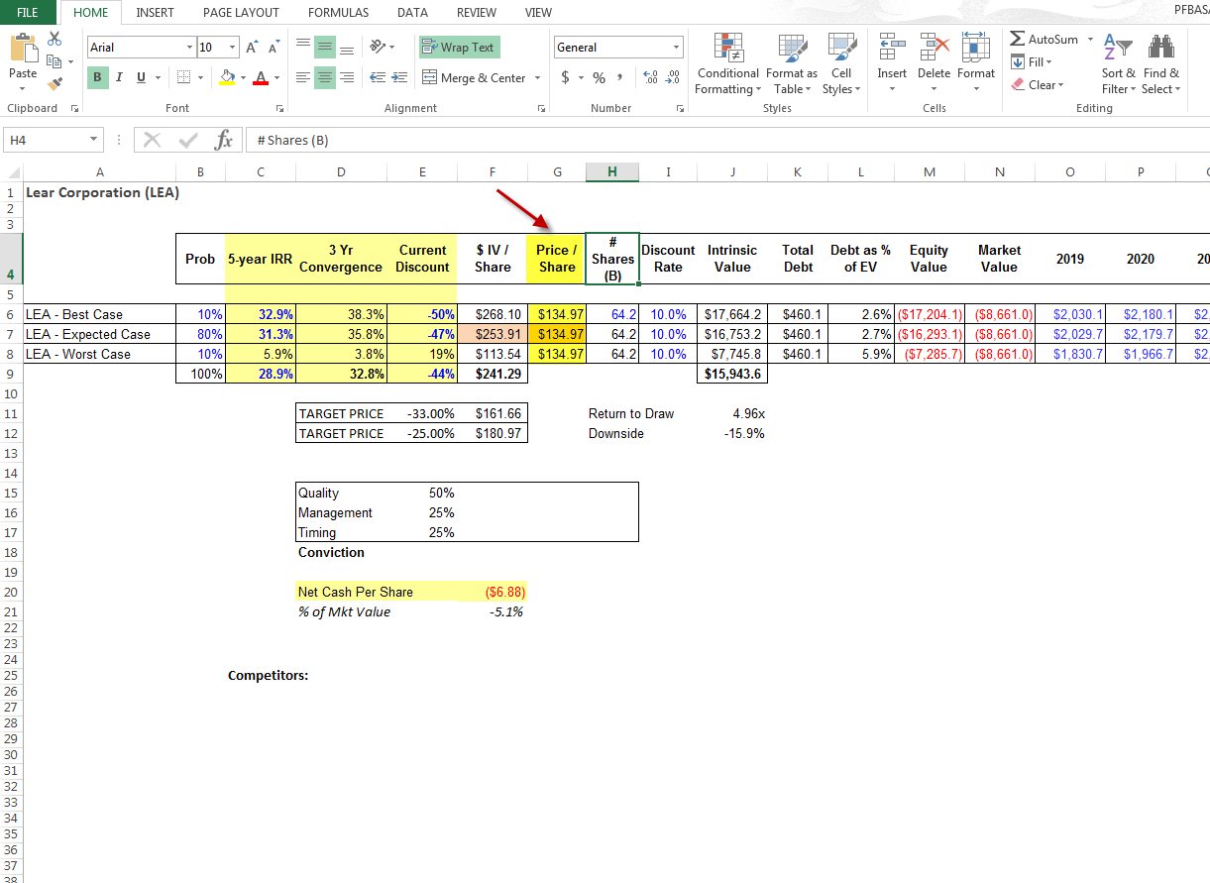
Inception (Founded Year) & HQ will mentioned at the bottom of the Profile page in yahoo finance. It should be entered at the expected sheet

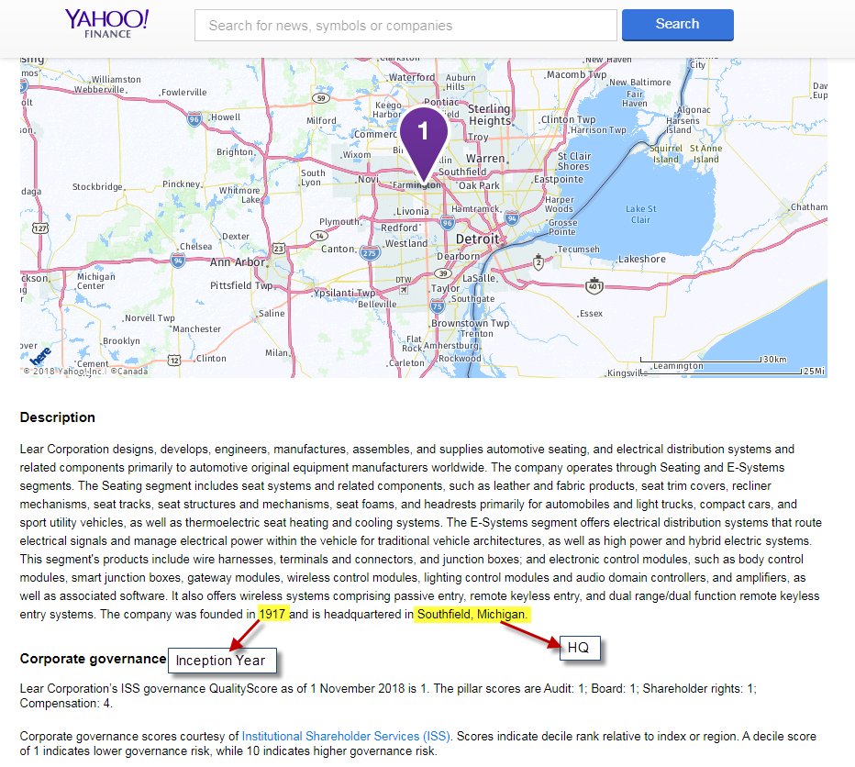
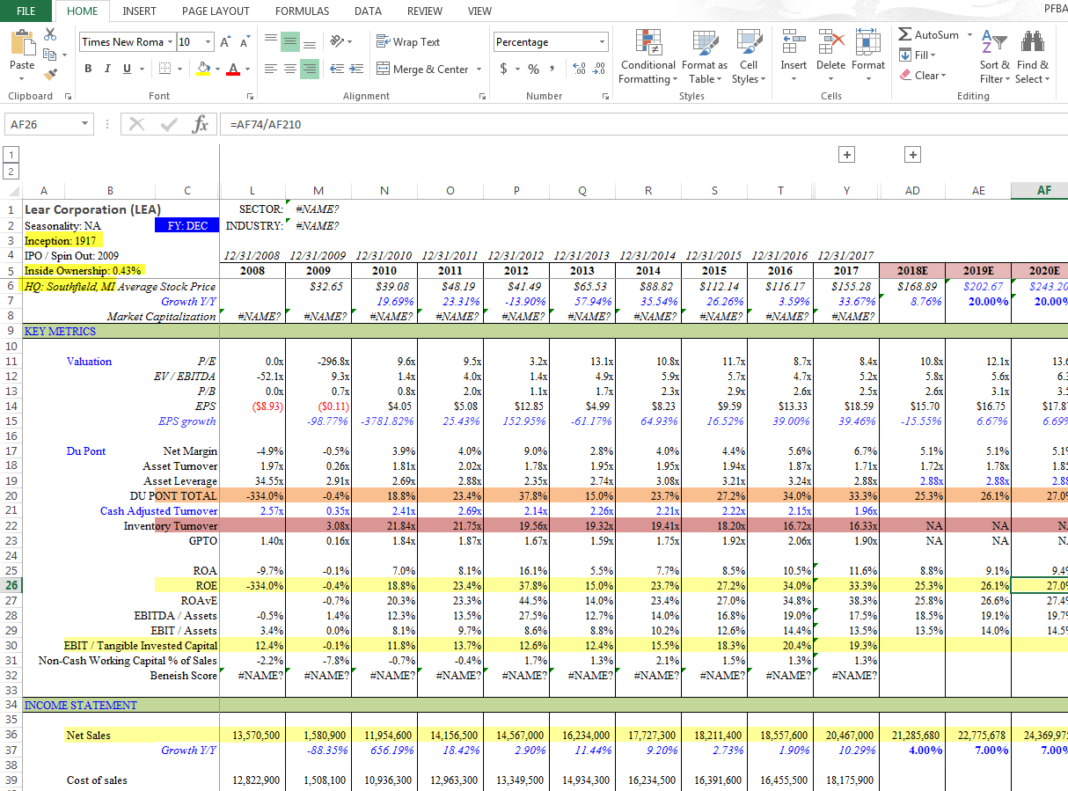
Inception & HQ will be entered as given below. Inside ownership is the recent year percentage of Directors and Executive Officers Ownership.

User Name & Pass Word for Ychart:
To know the value of EB/EBITDA on Valuation sheet, Go to Ychart and login with the respective user name & password. And enter the ticker at search box as given below
User Name: duncan@sunlightcapitalmanagement.com
Password: sunlightcap$
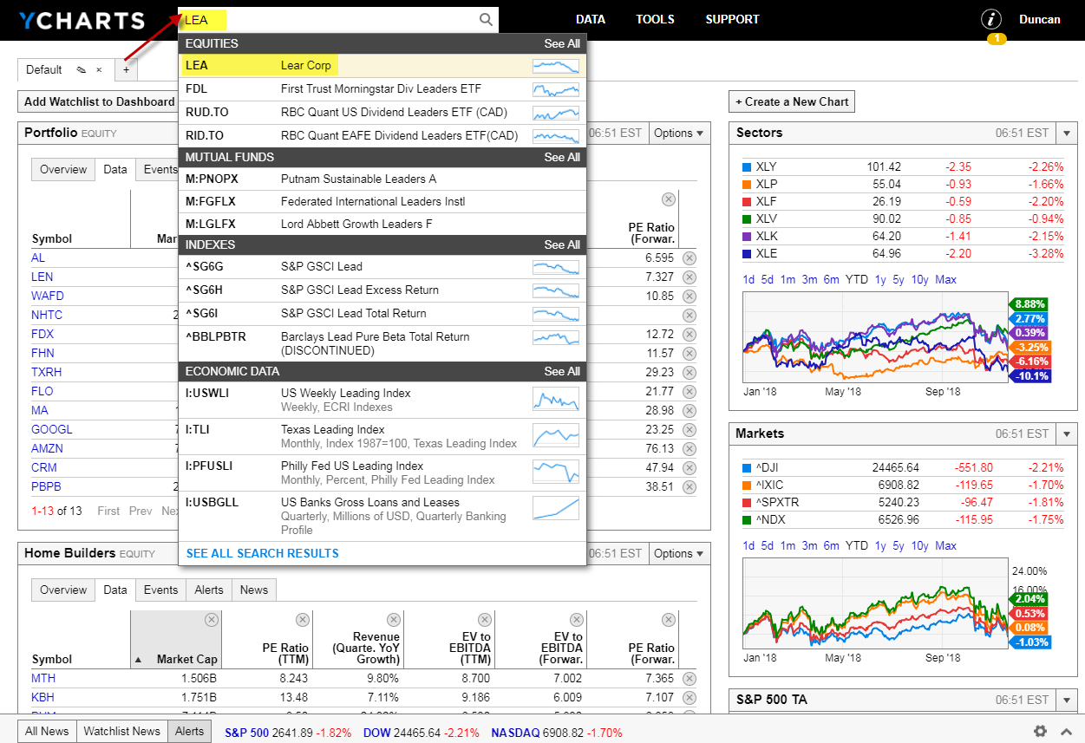
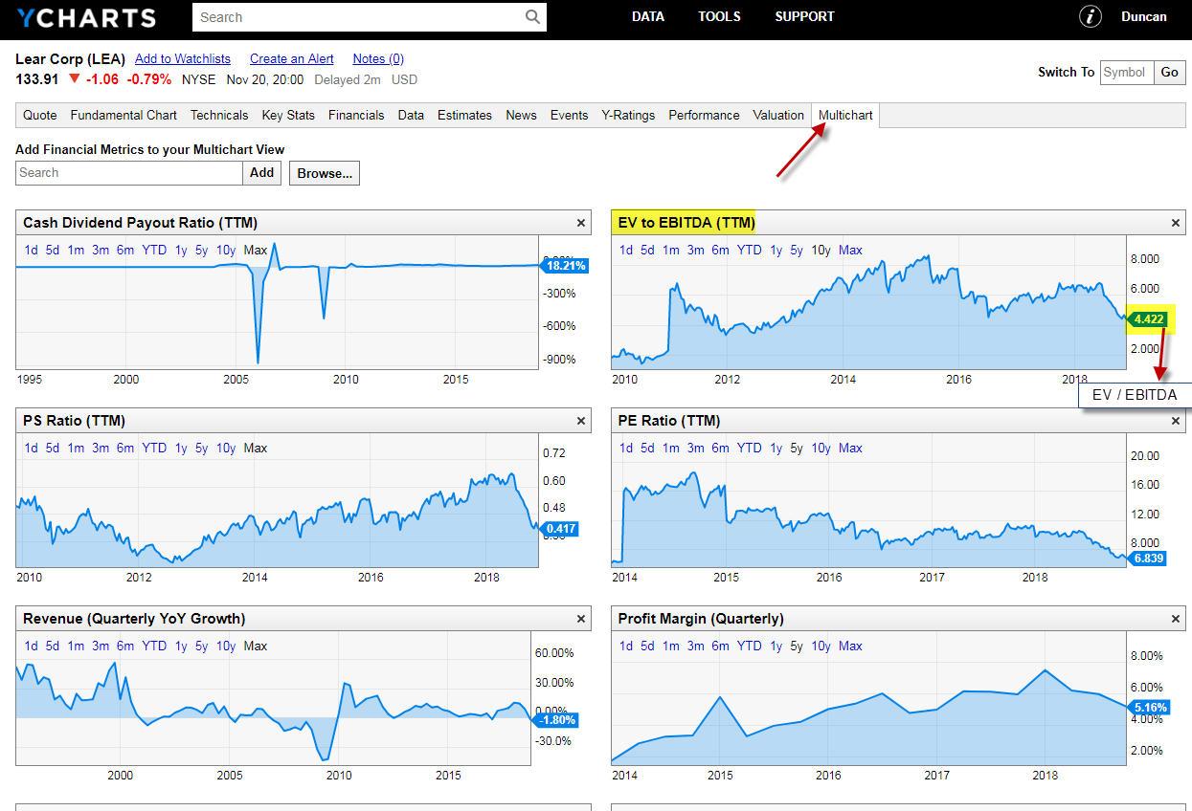
After opening the ticker, Select the multichart and take the value from the EV to EBITDA(TTM) as given below
After finding the EV/EBITDA value, change the EV/EBITDA values of best, expected & worst to make the sum value equal to the multichart value on ychart

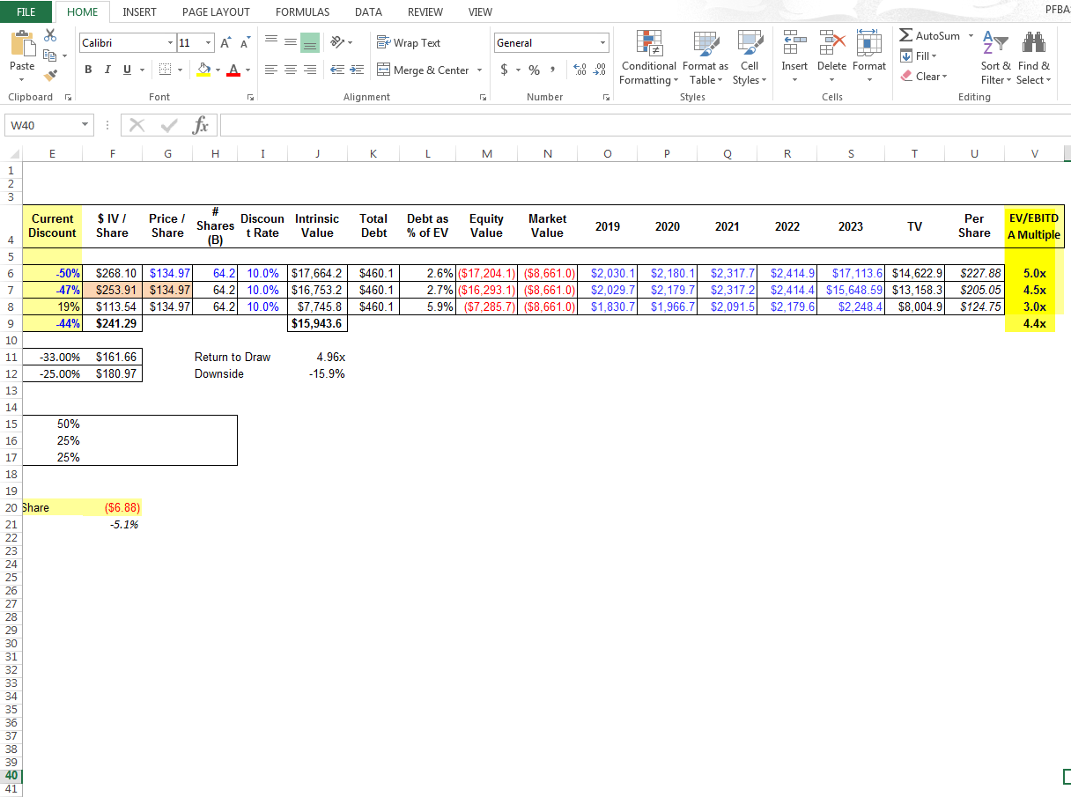
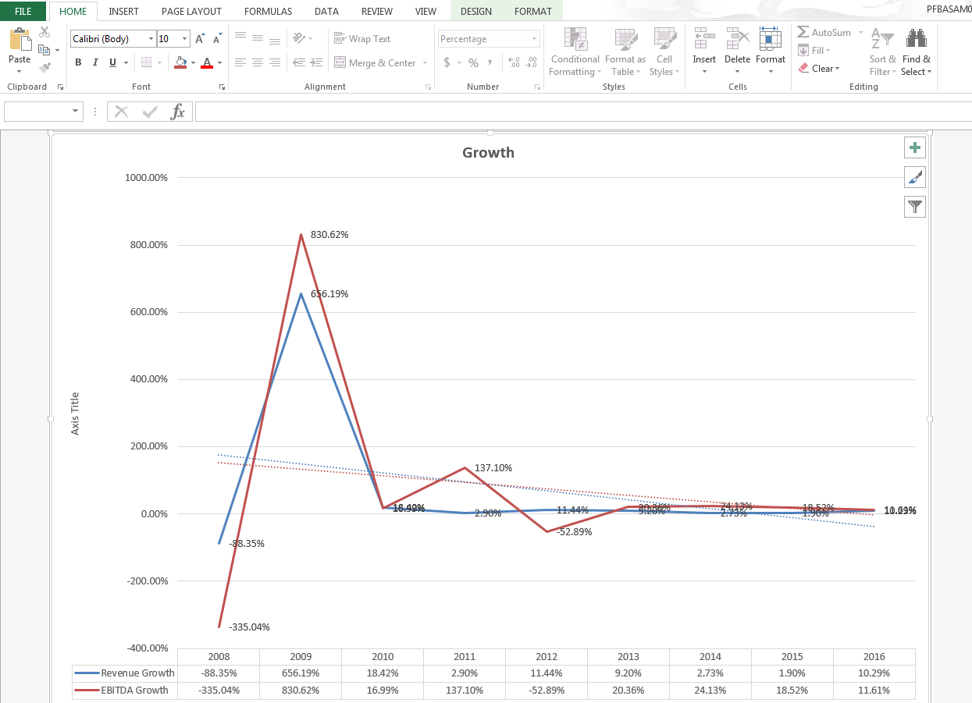
Create a chart with the Growth Y/Y percentage, of Revenue growth & EBITDA growth and named the chart as GROWTH. Add the Data Labels and Trendline to the lines.

Create a chart with the sale percentage, of all time Expenses and named the chart as Expenses. Add the Data Labels and Trend line to the lines.

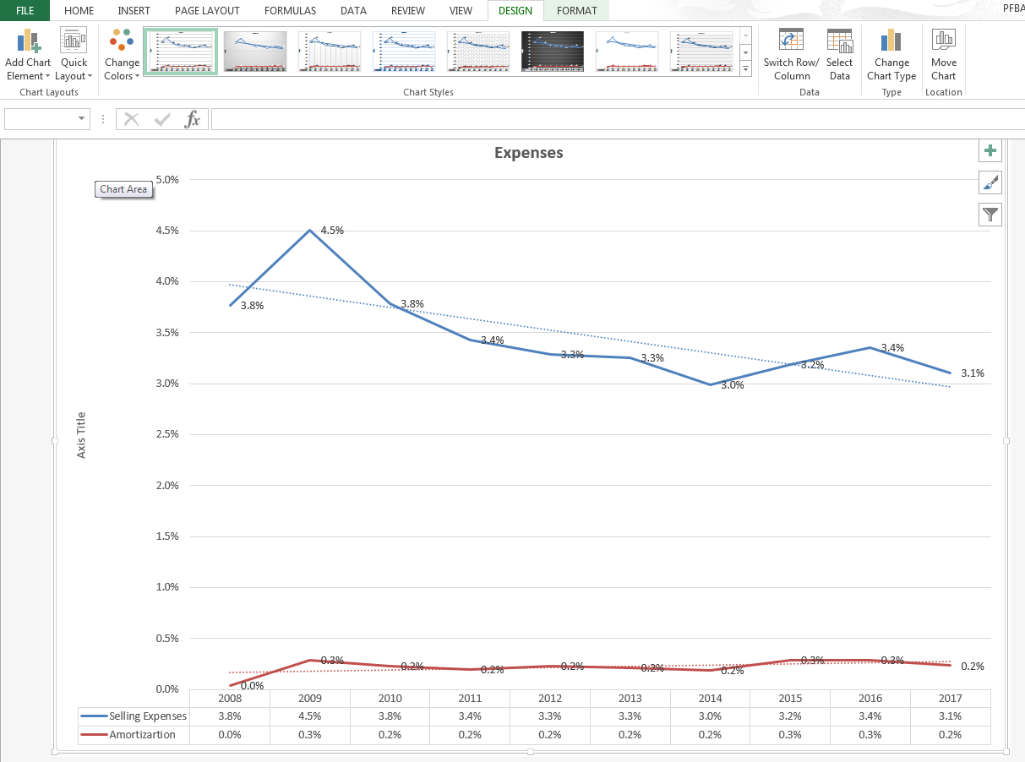
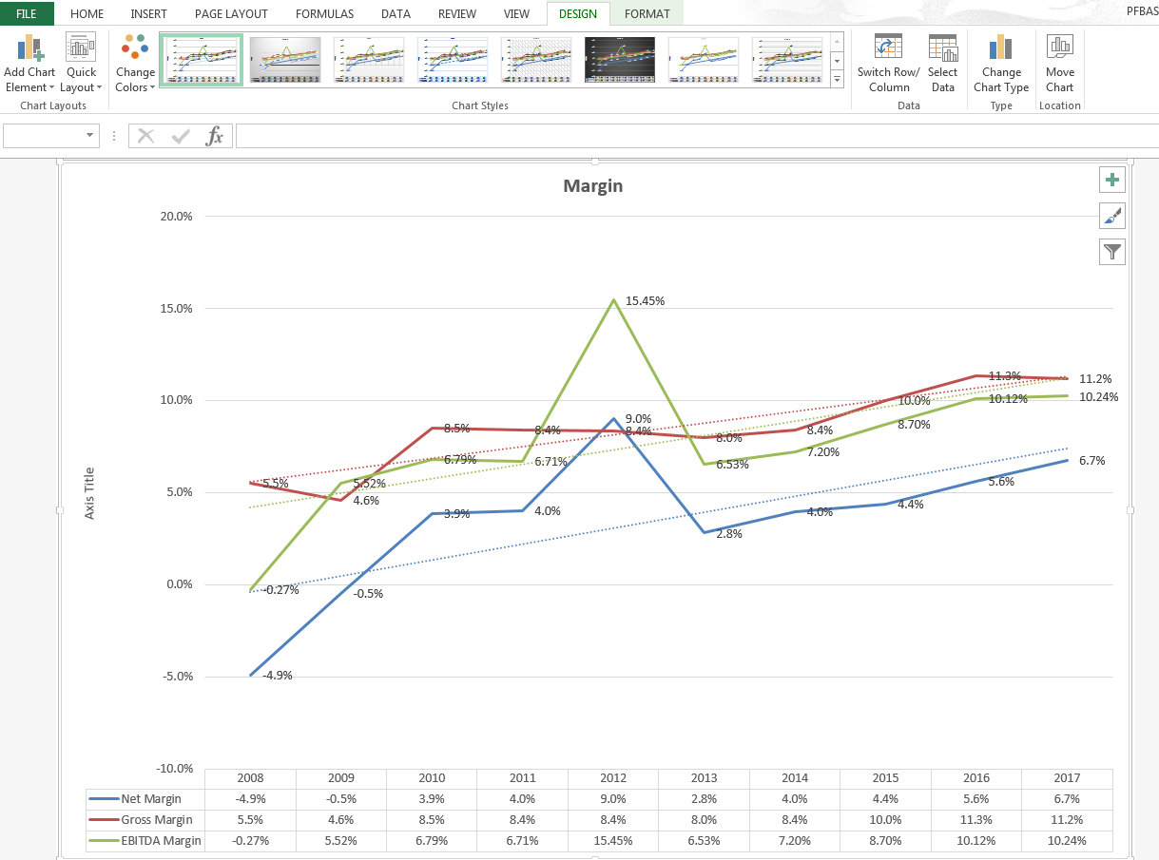
Create a chart with the sale percentage, of Net Margin, Gross Margin & EBITDA Margin and named the chart as Margin. Add the Data Labels and Trend line to the lines.

